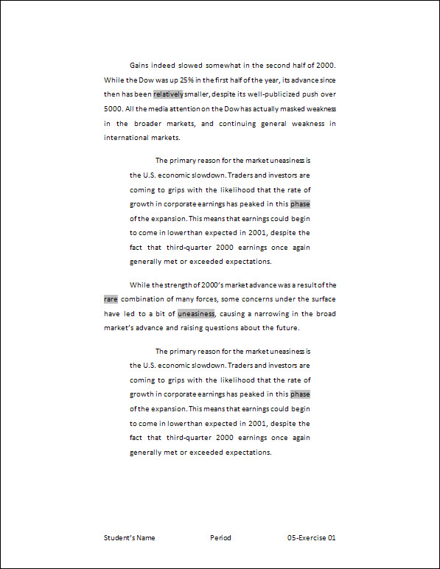
Exercise 1 {5 points}
- Open HandInOut\C-Nielsen\Hand-Out\CTech\Word\05-Strength.
- Save as My Documents\CTech\Word\5-1.
- Change the margins to “Wide”.
- Create a left and right indent of 0.5” in the 3rd paragraph.
- Cut the 2nd paragraph and paste it above the 1st paragraph.
- Hints:
- Select the 2nd paragraph
- Click the Cut button on the Quick Access Toolbar
- Move to the beginning of the 1st paragraph
- Click Paste on the Home tab, Clipboard group
- Be sure there is a blank line after the paragraph just pasted
- Copy the 3rd paragraph and paste it above the 2nd paragraph.
- Hints:
- Select the 3rd paragraph
- Click the Copy button on Quick Access Toolbar
- Move to the beginning of the 2nd paragraph
- Click Paste on the Quick Access Toolbar
- Be sure there is a blank line after the paragraph just pasted (see example below)
- Add a Blank (Three Column) Footer with your name, period, and “5-1”.
- Save again and close the document.

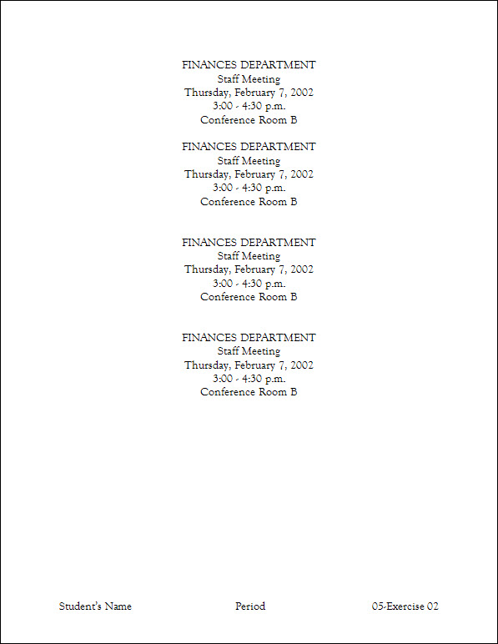
Exercise 2 {5 points}
- Open HandInOut\C-Nielsen\Hand-Out\CTech\Word\05-Block.
- Save as My Documents\CTech\Word\5-2.
- Change the font to 14-point Goudy Old Style for the whole document.
- Copy all of the text in the document.
- Hints:
- Select the document
- Click the Copy button on the Home tab, Clipboard group
- At the end of the document, paste 3 times.
- Hints:
- Move to the end of the document (Press Cmnd + End)
- Click Paste on the Home tab, Clipboard group
- Click Paste on the Home tab, Clipboard group
- Click Paste on the Home tab, Clipboard group
- Add a Blank (Three Column) Footer with your name, period, and “5-2”.
  - Change the font of the footer to 14-point Goudy Old Style.
- Save again and close the document.

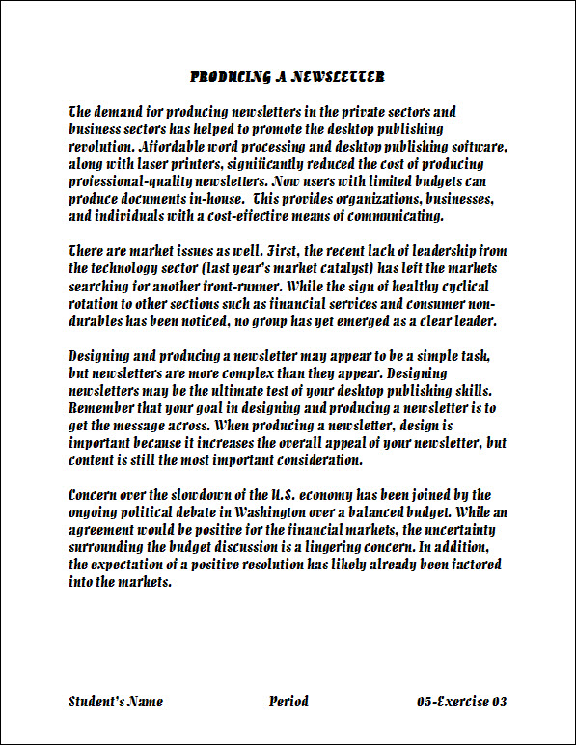
Exercise 3 {5 points}
- Open HandInOut\C-Nielsen\Hand-Out\CTech\Word\05-Concern.
- Using the Clipboard, copy the 1st and 2nd paragraphs and the space below the paragraph.
- Hints:
- Click the Scrapbook from the Toolbox
    - Click Delete any files in the Scrapbook
- Select the 1st paragraph and the space below the paragraph
      - Click the Add button, or drag the paragraph to the Scrapbook
- Select the 2nd paragraph and the space below the paragraph
      - Click the Add button, or drag the paragraph to the Scrapbook
- Close “05-Concern”
- Open HandInOut\C-Nielsen\Hand-Out\CTech\Word\05-Newsletter.
- Save as My Documents\CTech\Word\5-3.
- If necessary, view the Scrapbook.
- Hints:
- View Menu, Scrapbook
- Paste the 2nd paragraph (There are market…) in between the original paragraphs.
- Hints:
    - Click on Paragraph 2 (There are market…) to paste.
- Paste the 1st paragraph (Concern over the…) at the end of the document.
- Hints:
    - Click on Paragraph 1 (Concern over the…) to paste.
- Change the font to 14-point Apple Chancery for the whole document.
- Add a Blank (Three Column) Footer with your name, period, and “5- 3”.
        - Change the font of the footer to 14-point Apple Chancery.
- Save again and close the document.

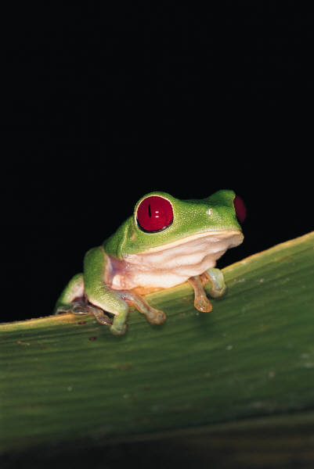
Exercise 4 {5 points}
- At a Blank Document, Insert this clip art image of a Tree Frog.
- Hints:
- Insert Menu, Clip Art, Clip Art Gallery
      - Search Animals, or Click Animals on the left side menu
          - Click the Tree Frog, then Insert
- Change the width of the picture to 4”.
- Hints:
- Select the graphic by clicking on it
- Click in the Width box on the Format Picture Tab, Size Group
      - Key in 4” and click on the graphic
- Rotate the picture 90° to the Right.
- Hints:
- Select the graphic by clicking on it
- Click Rotate (Circular Arrow) on the Format Picture Tab, Arrange Group
      - Click Rotate Right 90°
- Position the picture in Middle Center with Square Text Wrapping.
- Hints:
- Select the graphic by clicking on it
- Click Position on the Format Picture Tab, Arrange Group
      - Click Position in Middle Center with Square Text Wrapping
- Add a Blank (Three Column) Footer with your name, period, and “5-4”.
- Save as My Documents\CTech\Word\5-4.
- Save and close the document.
Exercise 5 {5 points}
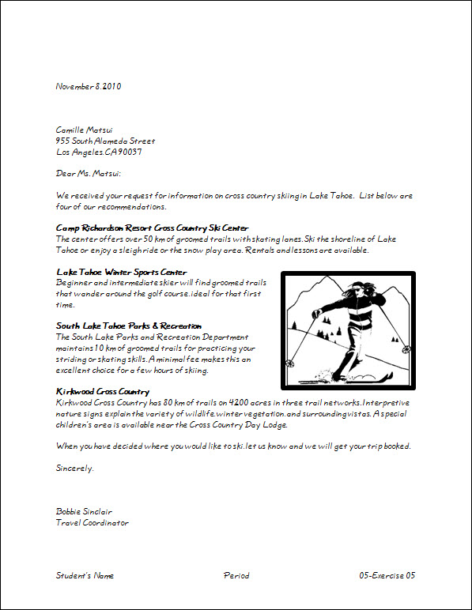
- Open HandInOut\C-Nielsen\Hand-Out\CTech\Word\ 05-Skiing
- Save as My Documents\CTech\Word\5-5.
- Insert the picture “skiing”
- Hints:
- Insert Menu, Photo…,Picture From File
      - At the Insert Picture dialog box, go to HandInOut\C-Nielsen\Hand-Out\CTech\Word
        - Click on “Skiing”
          - Click Ok
- Change the height to 2” for the picture
- Add a 6-point Border to the picture.
- Hints:
- Select the graphic by clicking on it
- Click Picture Border on the Format Picture Tab, Picture Styles Group
      - Click on Border, then Weight
              - Click on 6 pt
- Position the picture in Middle Right with Square Text Wrapping.
- Change the font of the document to one of your choice
  - Make sure the document stays on one page
- Add a Blank (Three Column) Footer with your name, period, and “5-5”.
  - Change the font of the footer to 12-point matching font to above
- Save again and close the document.

Exercise 6 {5 points}
- Open HandInOut\C-Nielsen\Hand-Out\CTech\Word\05-Computers.
- Save as My Documents\CTech\Word\5-6.
- Insert this clip art image of a boy on a computer.
- Change the height to 2” for the picture.
- Add a Double Frame Black Border to the picture.
- Hints:
- Select the graphic by clicking on it
- Click Double Frame Black on the Format Picture Tab, Picture Styles Group
- Position the picture in Top Left with Square Text Wrapping.
- Change the document to the font of your choice.
- Add a Blank (Three Column) Footer with your name, period, and “5-6”.
  - Change the font of the footer to 14-point matching font of your choice.
- Save again and close the document.

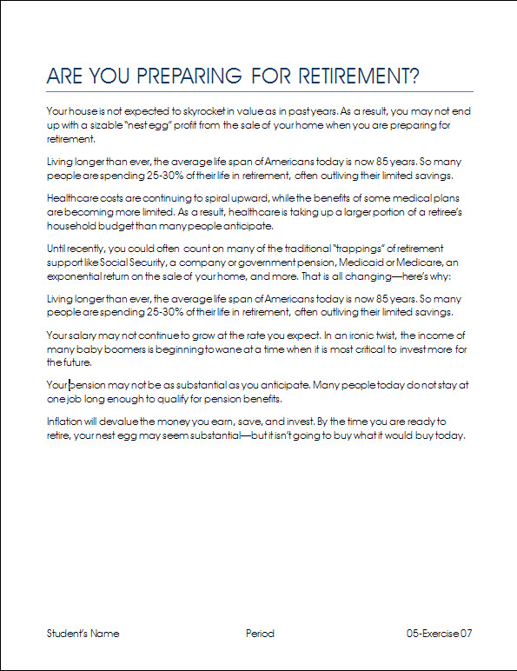
Exercise 7 {5 points}
- Open HandInOut\C-Nielsen\Hand-Out\CTech\Word\05-Preparing.
- Save as My Documents\CTech\Word\5-7.
- Change the margins to “Moderate”.
- Cut the 1st paragraph (Until recently…) and paste it as the 4th paragraph.
- Hints:
- Count the paragraphs starting with the 1st (below the title)
- Cut the 3rd paragraph (Your house…) and paste it as the 1st paragraph.
- Hints:
- Count the paragraphs starting with the 1st (below the title)
- Copy the 2nd paragraph (Living longer…) and paste it as the 5th paragraph.
- Hints:
- Count the paragraphs starting with the 1st (below the title)
- Change the document to the font of your choice.
- Add a Blank (Three Column) Footer with your name, period, and “5-7”.
  - Change the font of the footer to 12-point matching font of your choice
- Save again and close the document.

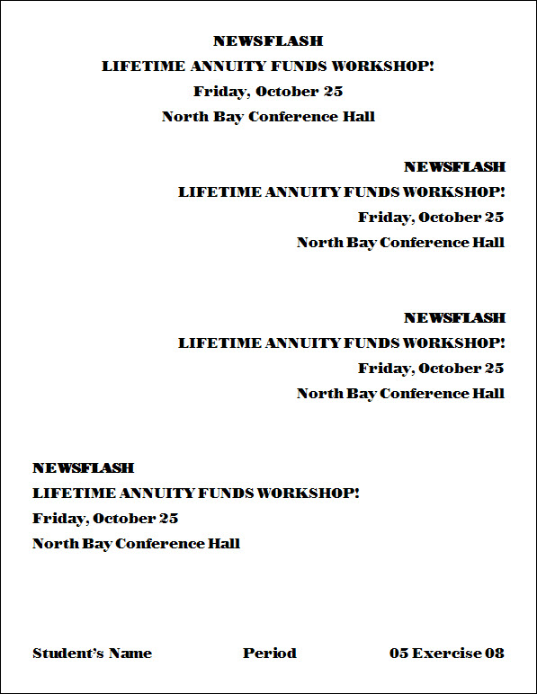
Exercise 8 {5 points}
- Open HandInOut\C-Nielsen\Hand-Out\CTech\Word\05-Workshop.
- Save as My Documents\CTech\Word\5-8.
- Copy all of the text in the document.
- At the end of the document, paste 3 times.
- Change the horizontal () alignment of all the 2nd and 3rd groups of text to right.
- Change the horizontal () alignment of the 4th group of text to left.
- Change the font of your document.
- Add a Blank (Three Column) Footer with your name, period, and “5-8”.
        - Change the font of the footer to 16-point matching font of your choice.
- Save again and close the document.
Exercise 9 {5 points}
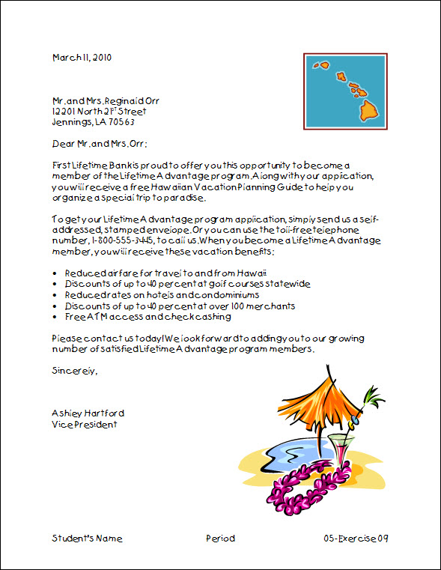
- Open HandInOut\C-Nielsen\Hand-Out\CTech\Word\05-Letter.
- Save as My Documents\CTech\Word\5-9.
- Insert a clip art image that goes with the letter.
- Change the height to 1.5” for the image.
- Position the picture in Top Right with Square Text Wrapping.
- Change the height to 3” for the Flowers of Hawaii picture.
- Position the picture in Bottom Right with Square Text Wrapping.
- Change the font of the document.
- Add a Blank (Three Column) Footer with your name, period, and “5-9”.
  - Change the font of the footer to 12-point matching font of your choice
- Save again and close the document.

Exercise 10 {5 points}
- Open HandInOut\C-Nielsen\Hand-Out\CTech\Word\05-Recycling.
- Save as My Documents\CTech\Word\5-10.
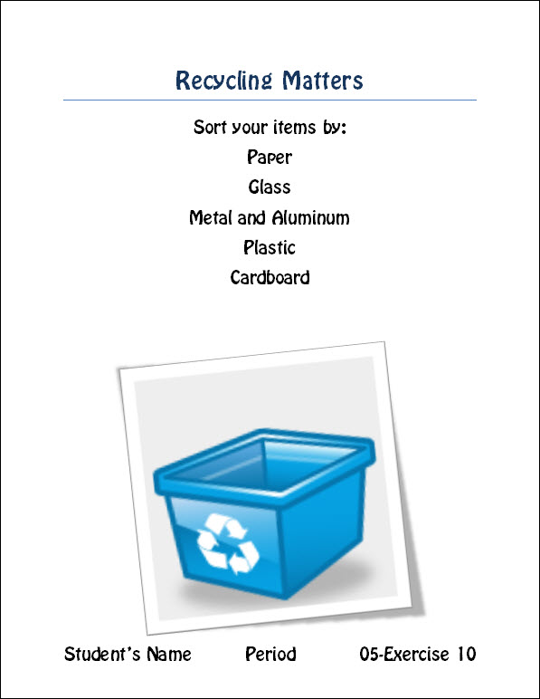
- Insert this clip art image of something to do with Recycling.
- Change the width to 4” for the picture.
- Add a Rotated, White Border to the picture.
- Hints:
- Select the graphic by clicking on it
- Click Rotated, White on the Format Picture Tab, Picture Styles Group
- Position the picture in Bottom Center with Square Text Wrapping.
- Change the font of the document.
- Add a Blank (Three Column) Footer with your name, period, and “5-10”.
  - Change the font of the footer to 20-point font of your choice.
- Save again and close the document.

Put all assignments in your named folder in the Hand-In for your period

