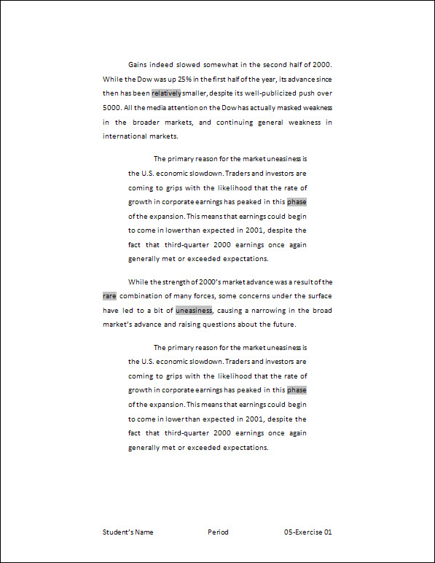Exercise 01 {5 points}

* Open Student Common\C Nielsen\CTech\Word\05-Strength.
* Save as V:\C Tech\Word\05- Exercise 01.
* Change the margins to “Wide”.
* Create a left and right indent of 0.5” in the 3rd paragraph.
* Cut the 2nd paragraph and paste it above the 1st paragraph.
* Hints:
* Select the 2nd paragraph
* Click the Cut button on the Home tab, Clipboard group
* Move to the beginning of the 1st paragraph
* Click Paste on the Home tab, Clipboard group
* Be sure there is a blank line after the paragraph just pasted
* Copy the 3rd paragraph and paste it above the 2nd paragraph.
* Hints:
* Select the 3rd paragraph
* Click the Copy button on the Home tab, Clipboard group
* Move to the beginning of the 2nd paragraph
* Click Paste on the Home tab, Clipboard group
* Be sure there is a blank line after the paragraph just pasted
* Add a Blank (Three Column) Footer with your name, period, and “05-Exercise 01”.
* Save again, print, and close the document.

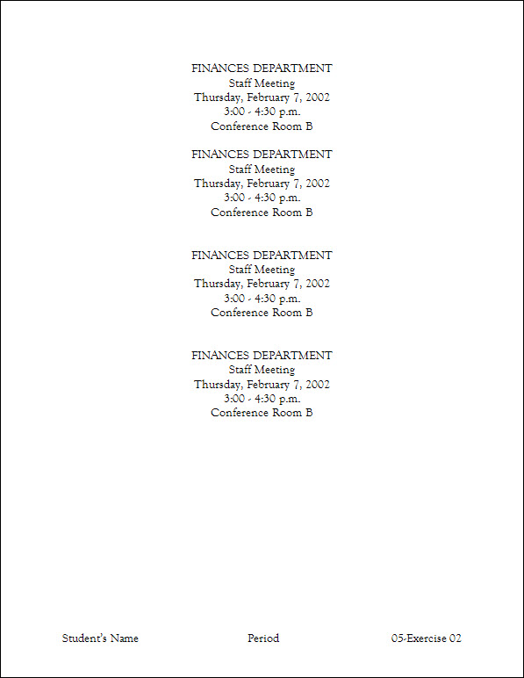Exercise 02 {5 points}

* Open Student Common\C Nielsen\CTech\Word\05-Block.
* Save as V:\C Tech\Word\05- Exercise 02.
* Change the font to 14-point Goudy Old Style for the whole document.
* Copy all of the text in the document.
* Hints:
* Select the document
* Click the Copy button on the Home tab, Clipboard group
* At the end of the document, paste 3 times.
* Hints:
* Move to the end of the document (Press Ctrl + End)
* Click Paste on the Home tab, Clipboard group
* Click Paste on the Home tab, Clipboard group
* Click Paste on the Home tab, Clipboard group
* Add a Blank (Three Column) Footer with your name, period, and “05-Exercise 02”.
  + Change the font of the footer to 14-point Goudy Old Style.
* Save again, print, and close the document.

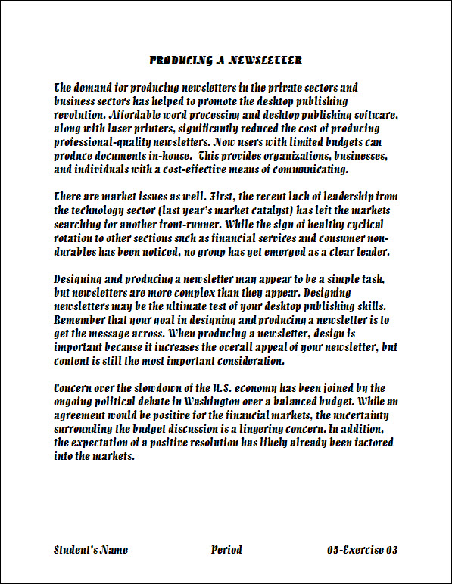Exercise 03 {5 points}

* Open Student Common\C Nielsen\CTech\Word\05-Concern.
* Using the Clipboard, copy the 1st and 2nd paragraphs and the space below the paragraph.
* Hints:
* Click the Clipboard task pane launcher on the Home Tab, Clipboard Group
  + - Click Clear All button on the Clipboard
* Select the 1st paragraph and the space below the paragraph
  + - * Click the Copy button on the Home tab, Clipboard group
* Select the 2nd paragraph and the space below the paragraph
  + - * Click the Copy button on the Home tab, Clipboard group
* Close “05-Concern”.
* Open Student Common\C Nielsen\CTech\Word\05-Newsletter.
* Save as V:\C Tech\Word\05- Exercise 03.
* If necessary, view the Clipboard.
* Hints:
* Click the Clipboard task pane launcher on the Home Tab, Clipboard Group
* Paste the 2nd paragraph (There are market…) in between the original paragraphs.
* Hints:
  + - Click on Paragraph 2 (There are market …) to paste.
* Paste the 1st paragraph (Concern over the…) at the end of the document.
* Hints:
  + - Click on Paragraph 1 (Concern over the …) to paste.
* Change the font to 16-point Allegro BT for the whole document.
* Add a Blank (Three Column) Footer with your name, period, and “05 Exercise 3”.
  + - * + Change the font of the footer to 16-point Allegro BT.
* Save again, print, and close the document.

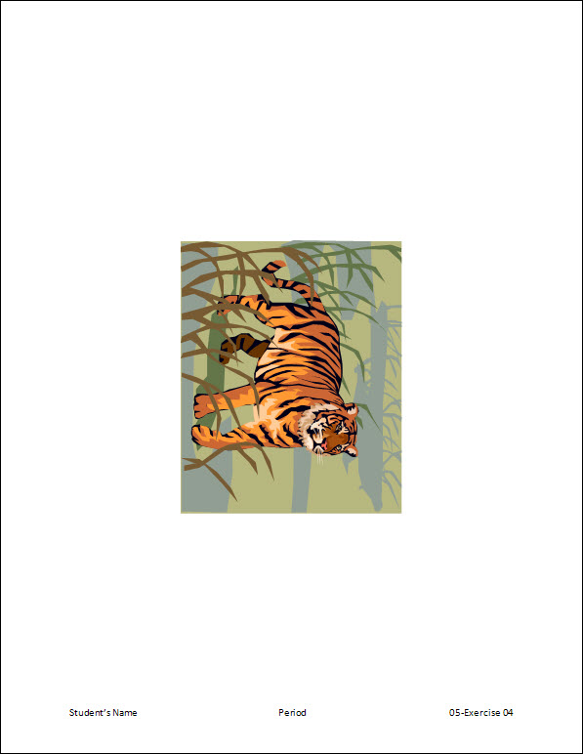

Exercise 04 {5 points}

* j0332364At a Blank Document, Insert this clip art image of a TIGER.
* Hints:
* Click Clip Art on the Insert Tab, Illustrations Group
  + - * At the Clip Art task pane, Search text: Type “Tiger”
        + Click Go

Click the Tiger to insert it onto the page

* Change the width of the picture to 4”.
* Hints:
* Select the graphic by clicking on it
* Click in the Width box on the Picture Tools Format Tab, Size Group
  + - * Key in 4” and click on the graphic
* Rotate the picture 90° to the Right.
* Hints:
* Select the graphic by clicking on it
* Click Rotate on the Picture Tools Format Tab, Arrange Group
  + - * Click Rotate Right 90°
* Position the picture in Middle Center with Square Text Wrapping.
* Hints:
* Select the graphic by clicking on it
* Click Position on the Picture Tools Format Tab, Arrange Group
  + - * Click Position in Middle Center with Square Text Wrapping
* Add a Blank (Three Column) Footer with your name, period, and “05- Exercise 04”.
* Save as V:\C Tech\Word\05-Exercise 04.
* Print, and close the document.

Exercise 05 {5 points}

* 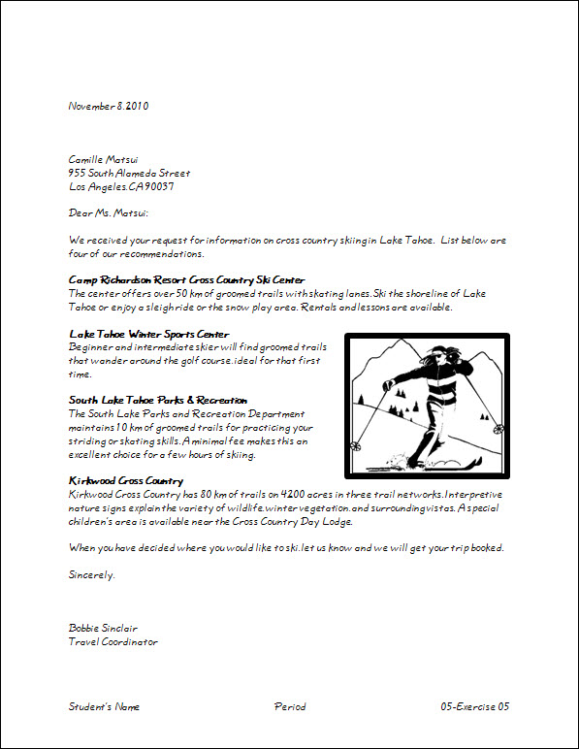Open Student Common\C Nielsen\CTech\Word\ 05-Skiing
* Save as V:\C Tech\Word\05- Exercise 05.
* Insert the picture “skiing”
* Hints:
* Click Picture on the Insert Tab, Illustrations Group
  + - * At the Insert Picture dialog box, go to Student Common\C Nielsen\CTech\Word
        + Click on “Skiing”

Click Ok

* Change the height to 2” for the picture
* Add a 6-point Border to the picture.
* Hints:
* Select the graphic by clicking on it
* Click Picture Border on the Picture Tools Format Tab, Picture Styles Group
  + - * Click on Weight

Click on 6 pt

* Position the picture in Middle Right with Square Text Wrapping.
* Add a Blank (Three Column) Footer with your name, period, and “05 Exercise 5”.
  + Change the font of the footer to 12-point Informal Roman.
* Save again, print, and close the document.

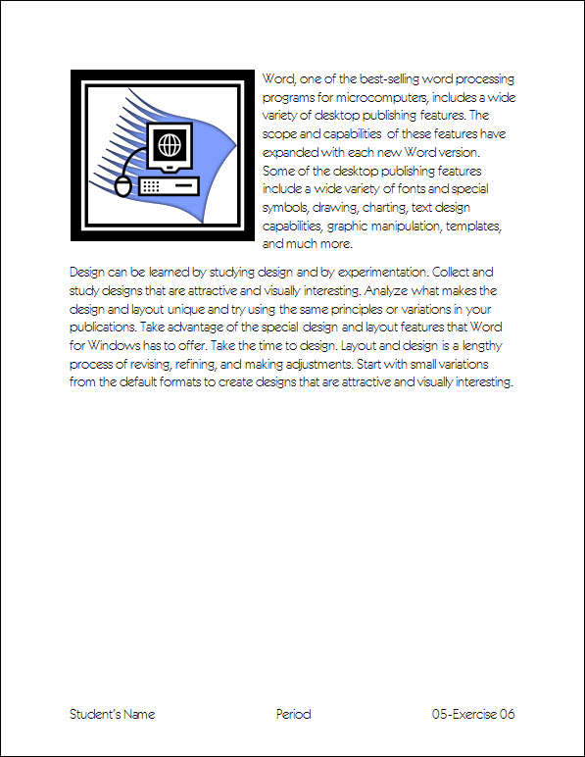Exercise 06 {5 points}

* Open Student Common\C Nielsen\CTech\Word\05-Computers.
* Save as V:\C Tech\Word\05- Exercise 06.
* j0205582Insert this clip art image of a COMPUTER.
* Change the height to 2” for the picture.
* Add a Double Frame Black Border to the picture.
* Hints:
* Select the graphic by clicking on it
* Click Double Frame Black on the Picture Tools Format Tab, Picture Styles Group
* Position the picture in Top Left with Square Text Wrapping.
* Add a Blank (Three Column) Footer with your name, period, and “05-Exercise 06”.
  + Change the font of the footer to 14-point Kazuka Gothic Pro H.
* Save again, print, and close the document.

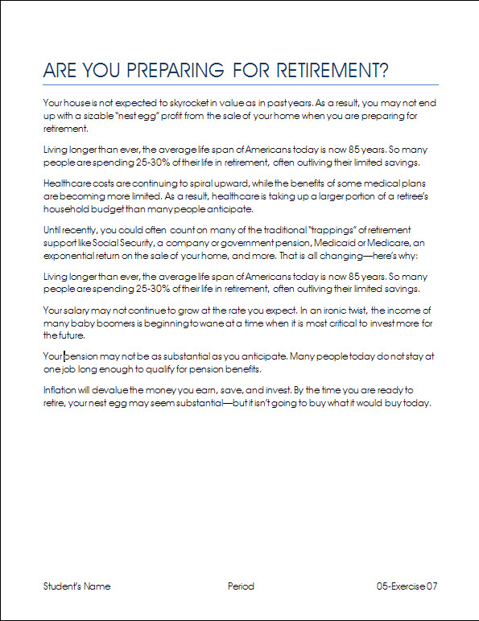Exercise 7 {5 points}

* Open Student Common\C Nielsen\CTech\Word\05-Preparing.
* Save as V:\C Tech\Word\05- Exercise 07.
* Change the margins to “Moderate”.
* Cut the 1st paragraph (Until recently…) and paste it as the 4th paragraph.
* Hints:
* Count the paragraphs starting with the 1st (below the title)
* Cut the 3rd paragraph ( Your house…) and paste it as the 1st paragraph.
* Hints:
* Count the paragraphs starting with the 1st (below the title)
* Copy the 2nd paragraph (Living longer…) and paste it as the 5th paragraph.
* Hints:
* Count the paragraphs starting with the 1st (below the title)
* Add a Blank (Three Column) Footer with your name, period, and “05-Exercise 07”.
  + Change the font of the footer to 12-point Aharoni.
* Save again, print, and close the document.

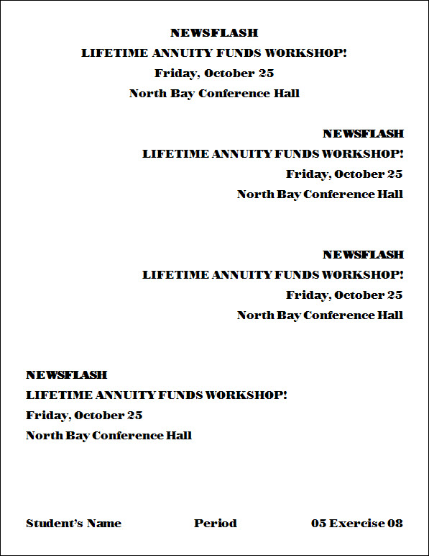Exercise 8 {5 points}

* Open Student Common\C Nielsen\CTech\Word\05-Workshop.
* Save as V:\C Tech\Word\05- Exercise 08.
* Copy all of the text in the document.
* At the end of the document, paste 3 times.
* Change the horizontal (⬄) alignment of all the 2nd and 3rd groups of text to right.
* Change the horizontal (⬄) alignment of the 4th group of text to left.
* Add a Blank (Three Column) Footer with your name, period, and “05-Exercise 08”.
  + - * + Change the font of the footer to 16-point font of your choice.
* Save again, print, and close the document.

Exercise 9 {5 points}

* 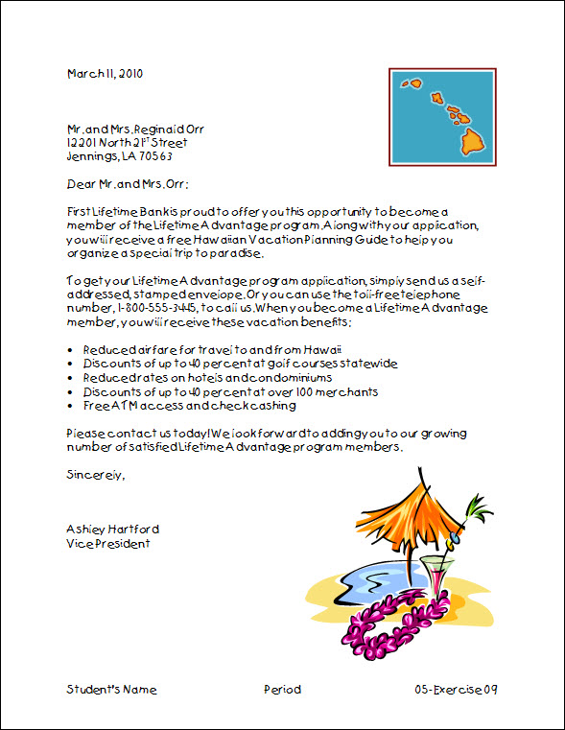Open Student Common\C Nielsen\CTech\Word\05-Letter.
* Save as V:\C Tech\Word\05- Exercise 09.
* C:\Documents and Settings\guymm779\Local Settings\Temporary Internet Files\Content.IE5\WHMJ8HQB\MCj04076280000[1].wmfInsert a clip art image of HAWAII that shows the islands.
* Change the height to 1.5” for the picture.
* Position the picture in Top Right with Square Text Wrapping.
* Change the height to 3” for the Flowers of Hawaii picture.
* Position the picture in Bottom Right with Square Text Wrapping.
* Add a Blank (Three Column) Footer with your name, period, and “05-Exercise 09”.
  + Change the font of the footer to 12-point Kristen ITC.
* Save again, print, and close the document.

Exercise 10 {5 points}

* Open Student Common\C Nielsen\CTech\Word\05-Recycling.
* Save as V:\C Tech\Word\05- Exercise 10.
* 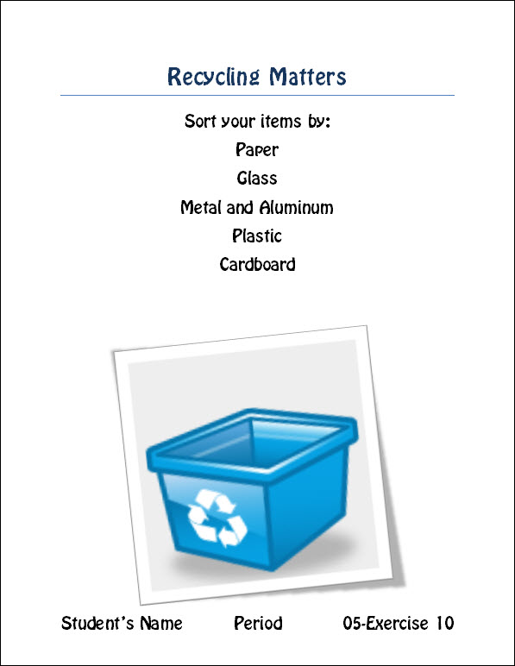Insert this clip art image of a Recycling.
* Change the width to 4” for the picture.
* Add a Rotated, White Border to the picture.
* Hints:
* Select the graphic by clicking on it
* Click Rotated, White on the Picture Tools Format Tab, Picture Styles Group
* Position the picture in Bottom Center with Square Text Wrapping.
* Add a Blank (Three Column) Footer with your name, period, and “05-Exercise 10”.
  + Change the font of the footer to 20-point font of your choice.
* Save again, print, and close the document.

Put all printout in order, staple with half sheet, turn into the basket.