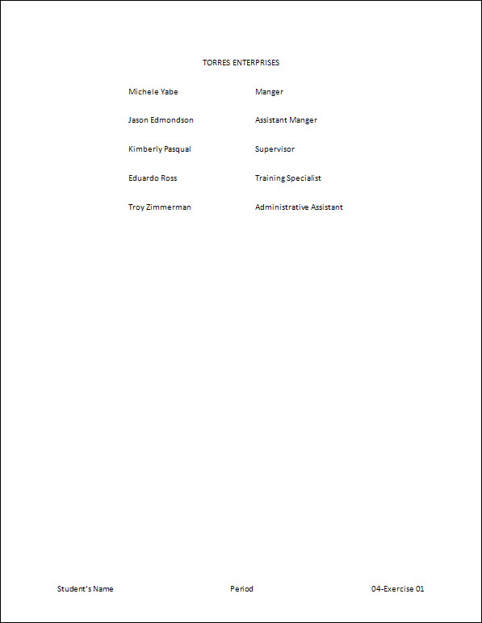
Exercise 01 {5 points}
- If not already visible, view the Ruler Bar.
- Hints:
  - View Menu, Check Ruler
- Start a new blank document.
- Hints:
- Press Cmnd + N to start a blank document (if you don’t already have one open)
- Set the following tabs: Left – 1.25”; Left – 3.5”.
- Hints:
- Format Menu, Tabs… (or the little tab icon above the vertical ruler on the left side)
        - Set a 1.25” Left Tab
          - Tab stop position: 1.25
          - Alignment: Left
          - Leader: None
            - Click Set
        - Set a 3.5” Left Tab
      - Click OK
- Type the following text making sure to capitalize, center, and tab as shown.

TORRES ENTERPRISES
Michele Yabe Manager
Jason Edmondson Assistant Manager
Kimberly Pasqual Supervisor
Eduardo Ross Training Specialist
Troy Zimmerman Administrative Assistant

- Change the line spacing for all the lines to 2.0.
- Add a Blank (Three Column) Footer with your name, period, and “4-1”.
- Save as My Documents\CTech\Word\4-1.
- Close the document.

Exercise 02 {5 points}
- If not already visible, view the Ruler Bar.
- Hints:
- View Menu, Check Ruler
- Start a new blank document. (Cmnd + N)
- Set the following tabs: Left – 0.5”; Center – 3.5”; Right – 6”.
- Type the following text, making sure to capitalize, center, underline and tab as shown.

WORKSHOPS
Class Date Cost
Quality Management February 5 $150
Staff Development February 12 $130
Streamlining Production March 1 $115
Managing Records March 27 $90

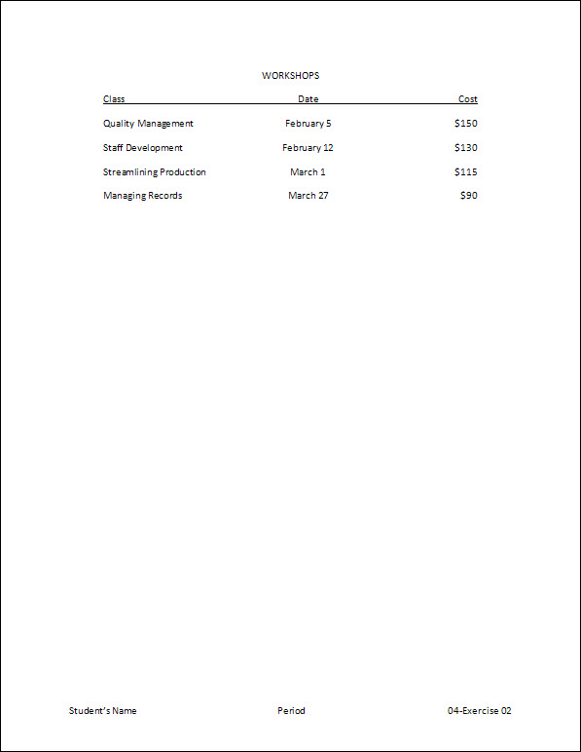
- Add a Blank (Three Column) Footer with your name, period, and “4-2”.
- Save as My Documents\CTech\Word\4-2.
- Close the document.

Exercise 03 {5 points}
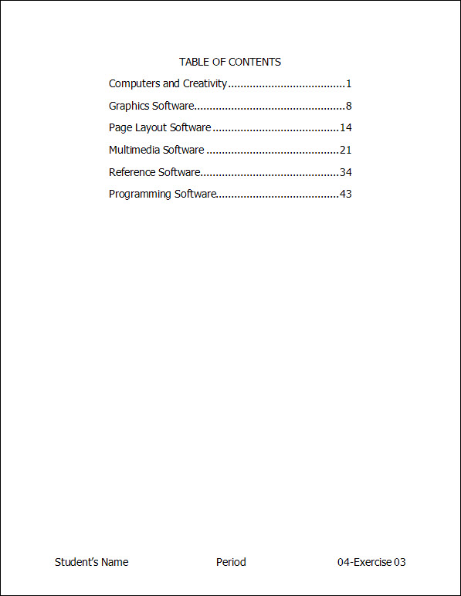
- If not already visible, view the Ruler Bar.
- Hints:
- View Menu, Check Ruler
- Start a new blank document.
- Set the following tabs: Left – 1”; Right – 5.5’’ Leader (you pick the leader).
- Type the following text, making sure to capitalize, center, and tab as shown.

TABLE OF CONTENTS
Computers and Creativity 1
Graphics Software 8
Page Layout Software 14
Multimedia Software 21
Educational and Reference Software 34
Programming Software 43

- Change the font to 14-point Tahoma for the whole document.
- Add a Blank (Three Column) Footer with your name, period, and “4-3”.
  - Change the font of the footer to 14-point Tahoma.
- Save as My Documents\CTech\Word\4-3.
- Close the document.
Exercise 04 {5 points}
- Open HandInOut\C-Nielsen\Hand-Out\CTech\Word\04-Training.
- Save as My Documents\CTech\Word\4-4.
- If not already visible, view the Ruler Bar.
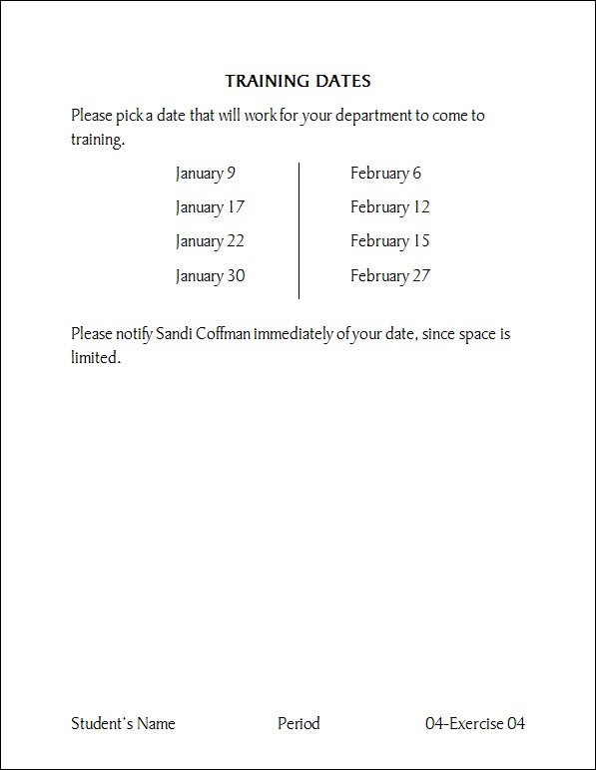
- Hints:
- View Menu, Check Ruler
- Between the paragraphs, set the following tabs: Left – 1.5”; Left – 4”; Bar – 3.25”.
- Type the following text, making sure to tab as shown.

January 9 February 6
January 17 February 12
January 22 February 15
January 30 February 27

- Add a Blank (Three Column) Footer with your name, period, and “4-4”.
  - Change the font of the footer to 18-point Bauhaus 93
- Save again and close the document.
Exercise 05 {5 points}
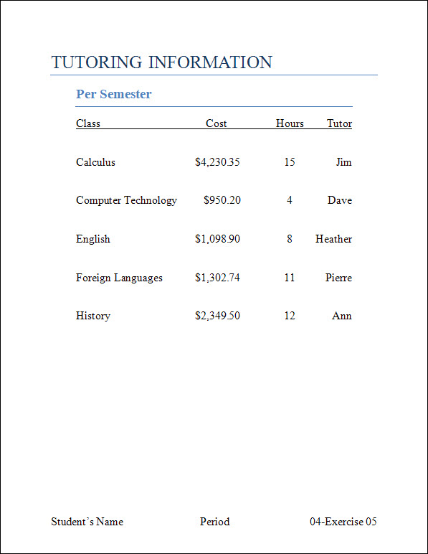
- Open HandInOut\C-Nielsen\Hand-Out\CTech\Word\04-Tutoring.
- Save as My Documents\CTech\Word\4-5.
- If not already visible, view the Ruler Bar.
- Using the ruler bar, move the 1” tab to 0.5”.
- Hints:
    - Select the text from “Class” to “Ann”
      - Click and drag the 1” tab to 0.5”
- Using the ruler bar, move the 3” tab to 3.5”.
- Hints:
    - Select the text from “Class” to “Ann”
      - Click and drag the 3” tab to 3.5”
- Using the ruler bar, move the 4” tab to 4.75”.
- Using the ruler bar, move the 5” tab to 6”.
- Add a Blank (Three Column) Footer with your name, period, and “4-5”.
  - Change the font of the footer to 16-point Times New Roman
- Save again and close the document.

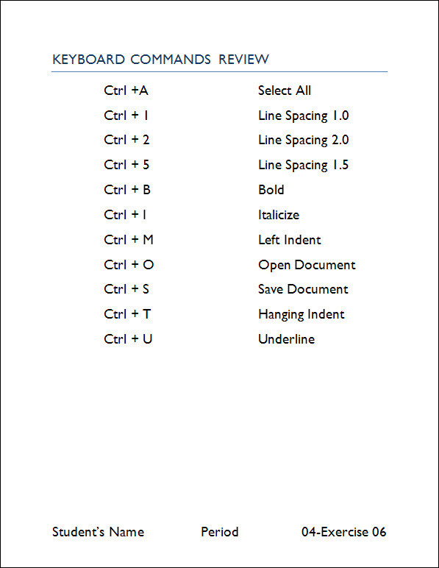
Exercise 06 {5 points}
- Open HandInOut\C-Nielsen\Hand-Out\CTech\Word\04-Commands.
- Save as My Documents\CTech\Word\4-6.
- If not already visible, view the Ruler Bar.
- Change the style of the title “Keyboard Commands Review” to Title.
- Change the font to 20-point Gill Sans MT for the whole document.
- Using the ruler bar, move the 2” tab to 1”.
- Hints:
    - Select the text from “Cmnd + A” to “Underline”
      - Click and drag the 2” tab to 1”
- Using the ruler bar, move the 3.25” tab to 4”.
- Add a Blank (Three Column) Footer with your name, period, and “4-6”.
  - Change the font of the footer to 20-point Gill Sans MT.
- Save again and close the document.
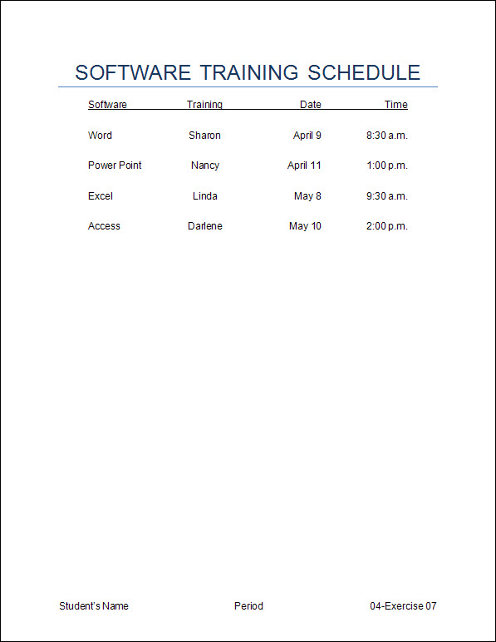
Exercise 7 {5 points}
- Open HandInOut\C-Nielsen\Hand-Out\CTech\Word\04-Software.
- Save as My Documents\CTech\Word\4-7.
- If not already visible, view the Ruler Bar.
- Set the following tabs for the whole document.
Left – 0.5”
Center – 2.5”
Right – 4.5”
Right – 6”
- Add a Blank (Three Column) Footer with your name, period, and “4-7”.
  - Change the font of the footer to 12-point Arial.
- Save again and close the document.

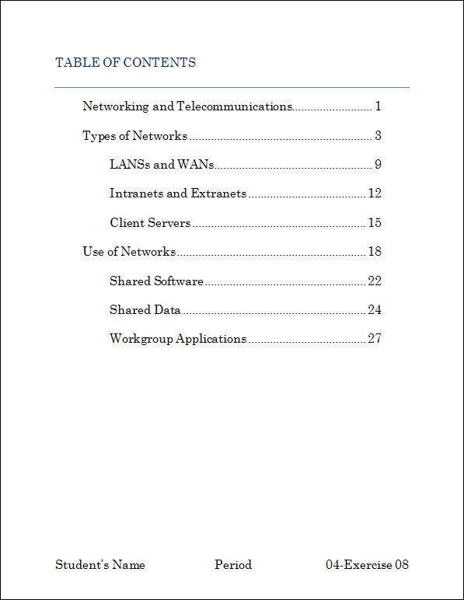
Exercise 8 {5 points}
- Open HandInOut\C-Nielsen\Hand-Out\CTech\Word\04-Contents.
- Save as My Documents\CTech\Word\4-8.
- If not already visible, view the Ruler Bar.
- Set the following tabs for the whole document.
Left – 0.5”
Left – 1”
Right – 6” Leader (you pick the leader).
- Change the font to 16-point Century Schoolbook for the whole document.
- Add a Blank (Three Column) Footer with your name, period, and “4-8”.
  - Change the font of the footer to 16-point Century Schoolbook.
- Save again and close the document.
Exercise 9 {5 points}
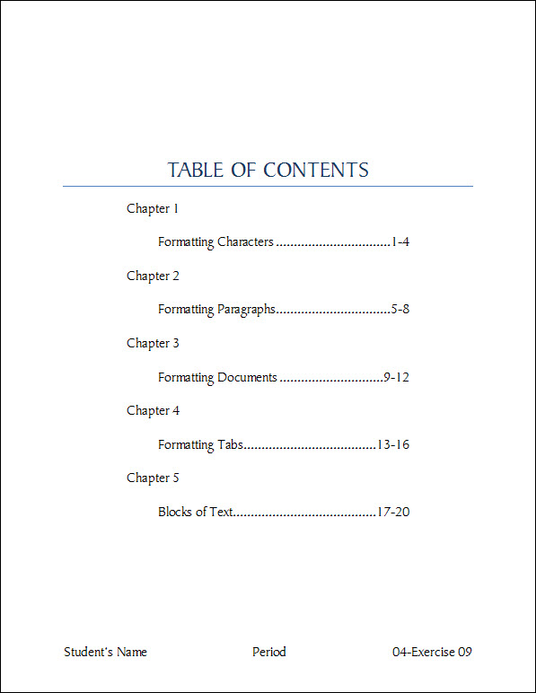
- Open HandInOut\C-Nielsen\Hand-Out\CTech\Word\04-Table.
- Save as My Documents\CTech\Word\4-9.
- If not already visible, view the Ruler Bar.
- Using the ruler bar, move the 0.5” tab to 1.5”.
- Using the ruler bar, move the 0.25” tab to 1”.
- Using the ruler bar, move the 6.25” tab to 5.5”.
- Vertically center () the document on the page.
- Hints:
- Format Menu, Document
      - Change the tab to Layout
        - In the middle-left section change, Vertical Alignment, Change to Center
          - Click OK
- Change the line spacing to 2.0
- Add a Blank (Three Column) Footer with your name, period, and “4-9”.
  - Change the font of the footer to 16-point Lucida Calligraphy.
- Save again and close the document.

Exercise 10 {5 points}
- Open HandInOut\C-Nielsen\Hand-Out\CTech\Word\ 04-States.
- Save as My Documents\CTech\Word\4-10.
- If not already visible, view the Ruler Bar.
- Set the following tabs for the whole document.
Left – 0.5”
Bar – 2”
Right – 3.5”
Left – 3.75”
Bar – 5.5”
Right – 7”
- Vertically center () the document on the page.
- Hints:
- Format Menu, Document
      - Change the tab to Layout
        - In the middle-left section, Vertical Alignment, Change to Center
          - Click OK
- Change the line spacing to 1.5
- Add a Blank (Three Column) Footer with your name, period, and “04-10”.
  - Change the font of the footer to 14-point American Typewriter.
- Save again and close the document.

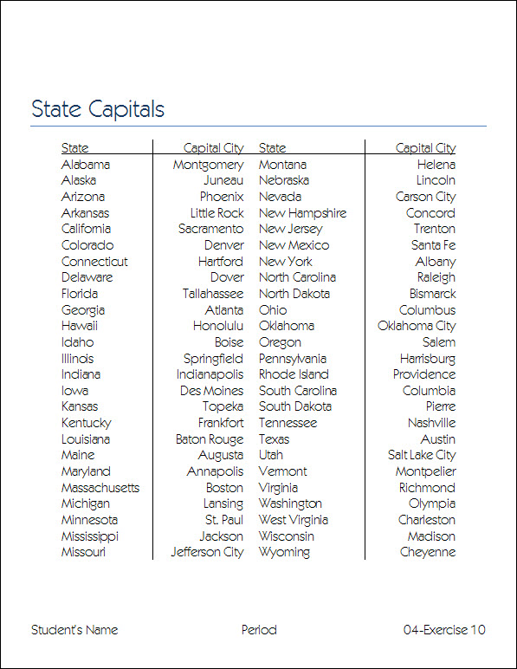

Turn all assignments into your named folder in the HandInOut, Hand-In Folder for your class.

