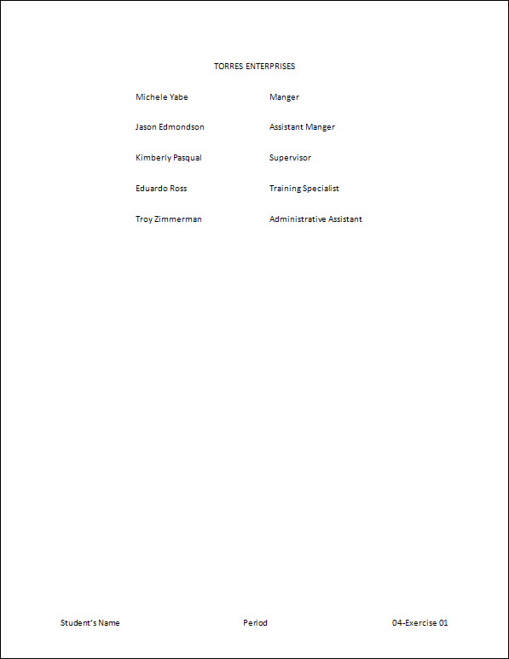
Exercise 01 {5 points}
- If not already visible, view the Ruler Bar.
- Hints:
- Check the Ruler box launcher on the View Tab, Show/Hide Group
- Start a new blank document.
- Hints:
- Press Ctrl + N to start a blank document
- Set the following tabs: Left – 1.25”; Left – 3.5”.
- Hints:
- Click the Paragraph dialog box launcher on the Home Tab, Paragraph Group
      - Click the Tabs button
        - Set a 1.25” Left Tab
          - Tab stop position: 1.25
          - Alignment: Left
          - Leader: None
            - Click Set
        - Set a 3.5” Left Tab
      - Click OK
- Type the following text, making sure to capitalize, center, and tab as shown.

TORRES ENTERPRISES
Michele Yabe Manager
Jason Edmondson Assistant Manager
Kimberly Pasqual Supervisor
Eduardo Ross Training Specialist
Troy Zimmerman Administrative Assistant

- Change the line spacing for all the lines to 2.0.
- Add a Blank (Three Column) Footer with your name, period, and “04-Exercise 01”.
- Save as V:\C Tech\Word\04-Exercise 01.
- Print, and close the document.

Exercise 02 {5 points}
- If not already visible, view the Ruler Bar.
- Hints:
- Check the Ruler box launcher on the View Tab, Show/Hide Group
- Start a new blank document.
- Set the following tabs: Left – 0.5”; Center – 3.5”; Right – 6”.
- Type the following text, making sure to capitalize, center, underline and tab as shown.

WORKSHOPS
Class Date Cost
Quality Management February 5 $150
Staff Development February 12 $130
Streamlining Production March 1 $115
Managing Records March 27 $90

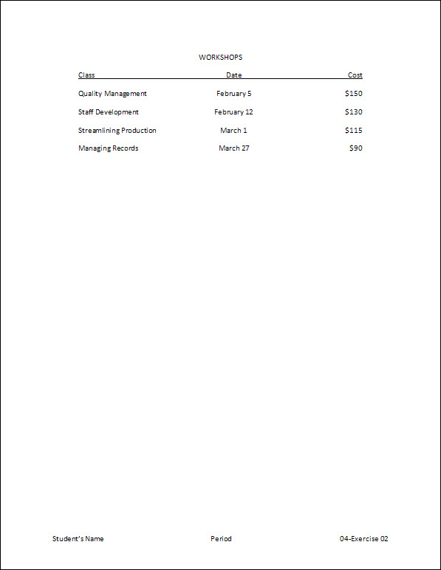
- Add a Blank (Three Column) Footer with your name, period, and “04-Exercise 02”.
- Save as V:\C Tech\Word\04-Exercise 02.
- Print, and close the document.

Exercise 03 {5 points}
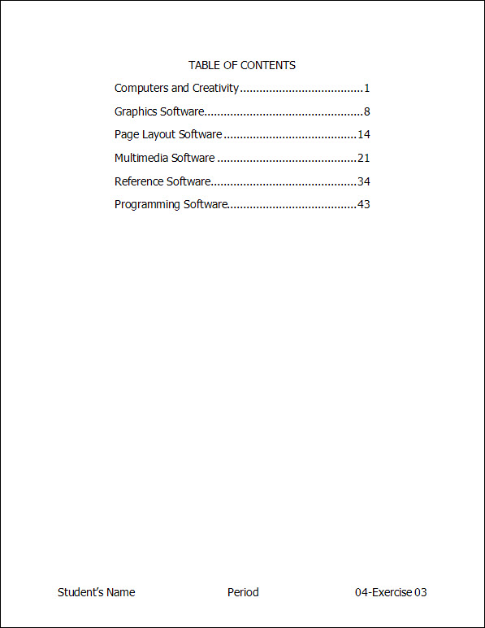
- If not already visible, view the Ruler Bar.
- Hints:
- Check the Ruler box launcher on the View Tab, Show/Hide Group
- Start a new blank document.
- Set the following tabs: Left – 1”; Right – 5.5’’ Leader (you pick the leader).
- Type the following text, making sure to capitalize, center, and tab as shown.

TABLE OF CONTENTS
Computers and Creativity 1
Graphics Software 8
Page Layout Software 14
Multimedia Software 21
Educational and Reference Software 34
Programming Software 43

- Change the font to 14-point Tahoma for the whole document.
- Add a Blank (Three Column) Footer with your name, period, and “04-Exercise 03”.
  - Change the font of the footer to 14-point Tahoma.
- Save as V:\C Tech\Word\04-Exercise 03.
- Print, and close the document.
Exercise 04 {5 points}
- Open Student Common\C Nielsen\CTech\Word\04-Training.
- Save as V:\C Tech\Word\04- Exercise 04.
- If not already visible, view the Ruler Bar.
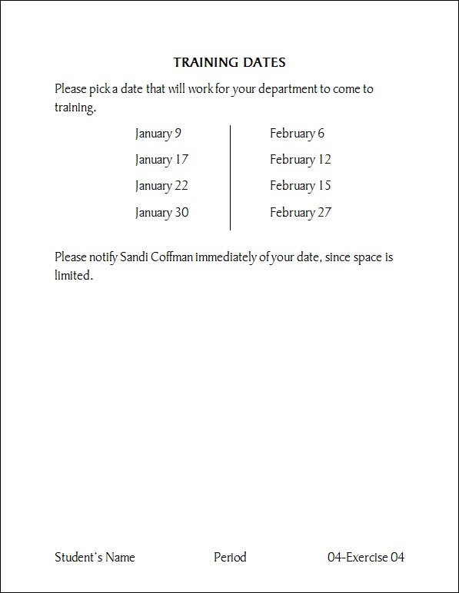
- Hints:
- Check the Ruler box launcher on the View Tab, Show/Hide Group
- Between the paragraphs, set the following tabs: Left – 1.5”; Left – 4”; Bar – 3.25”.
- Type the following text, making sure to tab as shown.

January 9 February 6
January 17 February 12
January 22 February 15
January 30 February 27

- Add a Blank (Three Column) Footer with your name, period, and “04-Exercise 04”.
  - Change the font of the footer to 18-point Bauhaus 93
- Save again, print, and close the document.
Exercise 05 {5 points}
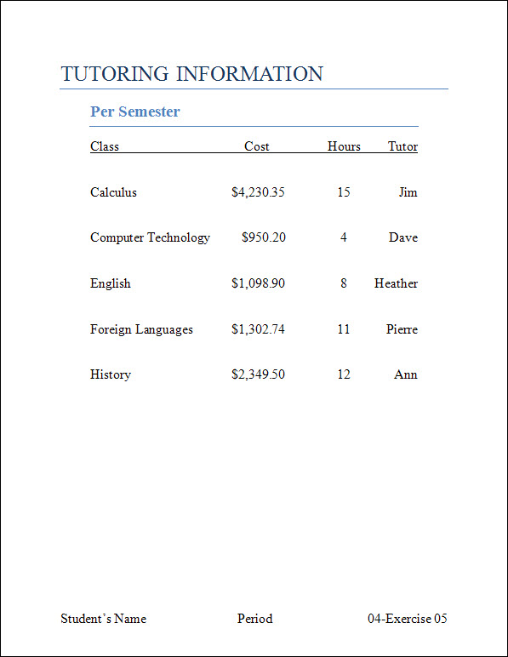
- Open Student Common\C Nielsen\CTech\Word\04-Tutoring.
- Save as V:\C Tech\Word\04- Exercise 05.
- If not already visible, view the Ruler Bar.
- Using the ruler bar, move the 1” tab to 0.5”.
- Hints:
    - Select the text from “Class” to “Ann”
      - Click and drag the 1” tab to 0.5”
- Using the ruler bar, move the 3” tab to 3.5”.
- Hints:
    - Select the text from “Class” to “Ann”
      - Click and drag the 3” tab to 3.5”
- Using the ruler bar, move the 4” tab to 4.75”.
- Using the ruler bar, move the 5” tab to 6”.
- Add a Blank (Three Column) Footer with your name, period, and “04-Exercise 05”.
  - Change the font of the footer to 16-point Times New Roman
- Save again, print, and close the document.

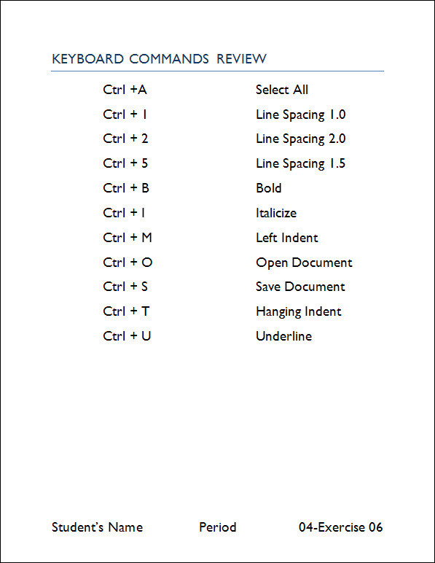
Exercise 06 {5 points}
- Open Student Common\C Nielsen\CTech\Word\04-Commands.
- Save as V:\C Tech\Word\04- Exercise 06.
- If not already visible, view the Ruler Bar.
- Change the style of the title “Keyboard Commands Review” to Title.
- Change the font to 20-point Gill Sans MT for the whole document.
- Using the ruler bar, move the 2” tab to 1”.
- Hints:
    - Select the text from “Ctrl + A” to “Underline”
      - Click and drag the 2” tab to 1”
- Using the ruler bar, move the 3.25” tab to 4”.
- Add a Blank (Three Column) Footer with your name, period, and “04-Exercise 06”.
  - Change the font of the footer to 20-point Gill Sans MT.
- Save again, print, and close the document.
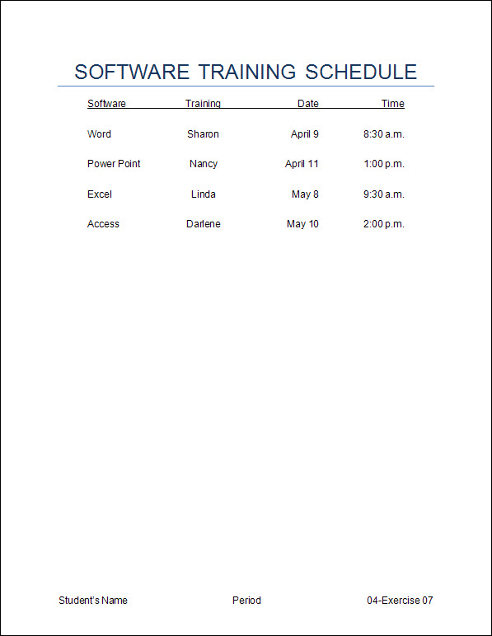
Exercise 7 {5 points}
- Open Student Common\C Nielsen\CTech\Word\04-Software.
- Save as V:\C Tech\Word\04- Exercise 07.
- If not already visible, view the Ruler Bar.
- Set the following tabs for the whole document.
Left – 0.5”
Center – 2.5”
Right – 4.5”
Right – 6”
- Add a Blank (Three Column) Footer with your name, period, and “04-Exercise 07”.
  - Change the font of the footer to 12-point Arial.
- Save again, print, and close the document.

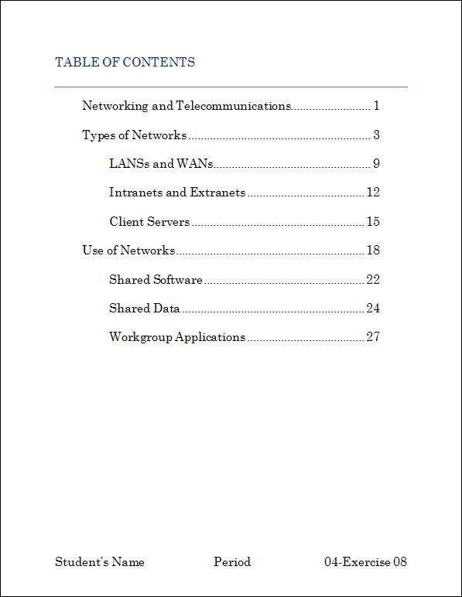
Exercise 8 {5 points}
- Open Student Common\C Nielsen\CTech\Word\04-Contents.
- Save as V:\C Tech\Word\04- Exercise 08.
- If not already visible, view the Ruler Bar.
- Set the following tabs for the whole document.
Left – 0.5”
Left – 1”
Right – 6” Leader (you pick the leader).
- Change the font to 16-point Century Schoolbook for the whole document.
- Add a Blank (Three Column) Footer with your name, period, and “04-Exercise 08”.
  - Change the font of the footer to 16-point Century Schoolbook.
- Save again, print, and close the document.
Exercise 9 {5 points}
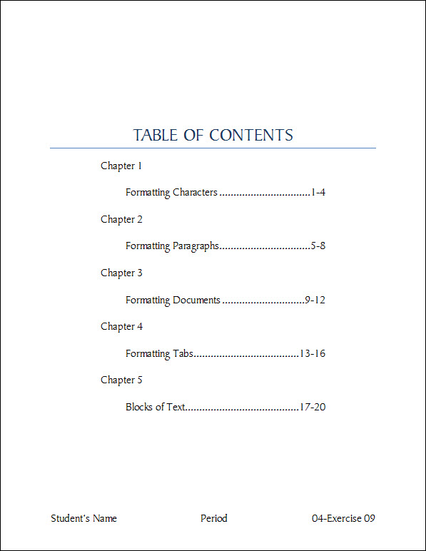
- Open Student Common\C Nielsen\CTech\Word\04-Table.
- Save as V:\C Tech\Word\04- Exercise 09.
- If not already visible, view the Ruler Bar.
- Using the ruler bar, move the 0.5” tab to 1.5”.
- Using the ruler bar, move the 0.25” tab to 1”.
- Using the ruler bar, move the 6.25” tab to 5.5”.
- Vertically center () the document on the page.
- Hints:
- Click the Page Setup dialog box launcher on the Page Layout Tab, Page Setup Group
      - Change the tab to Layout
        - Under the Page Section, Vertical Alignment, Change to Center
          - Click OK
- Add a Blank (Three Column) Footer with your name, period, and “04-Exercise 09”.
  - Change the font of the footer to 16-point Batang.
- Save again, print, and close the document.

Exercise 10 {5 points}
- Open Student Common\C Nielsen\CTech\Word\ 04-States.
- Save as V:\C Tech\Word\04- Exercise 10.
- If not already visible, view the Ruler Bar.
- Set the following tabs for the whole document.
Left – 0.5”
Bar – 2”
Right – 3.5”
Left – 3.75”
Bar – 5.5
Right – 7”
- Vertically center () the document on the page.
- Hints:
- Click the Page Setup dialog box launcher on the Page Layout Tab, Page Setup Group
      - Change the tab to Layout
        - Under the Page Section, Vertical Alignment, Change to Center
          - Click OK
- Add a Blank (Three Column) Footer with your name, period, and “04-Exercise 10”.
  - Change the font of the footer to 16-point Kabel Bk BT.
- Save again, print, and close the document.

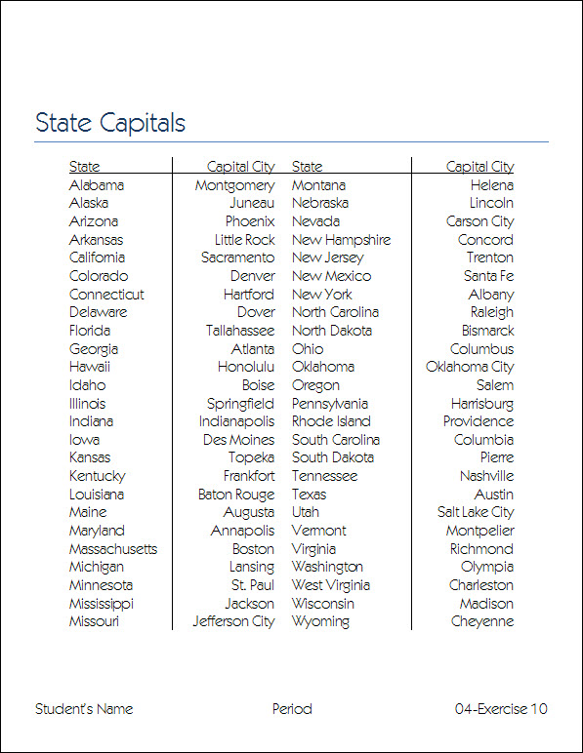

Put all printout in order, staple with half sheet, turn into the basket.

