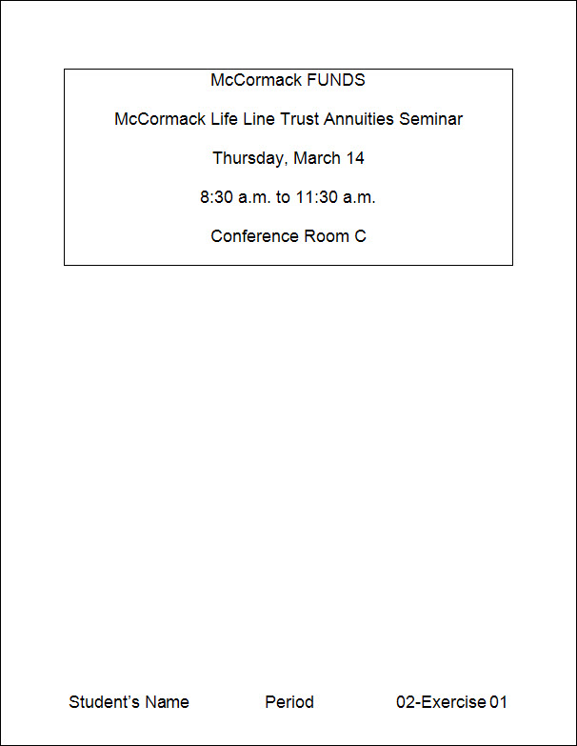
Exercise 01 {5 points}
- Open HandInOut\C-Nielsen\Hand-Out\CTech\Word\02-Funds.
- Save as V:\CTech\Word\02-01.
- Click the Show/Hide button to display the nonprinting characters.
  - Hints:
    - Click Show/Hide button on the Quick Access Toolbar
- Change the font to 18-point Arial for the whole document.
- Change the horizontal () alignment of all the lines of text to center.
  - Hints:
    - Select the whole document (Cmnd + A)
    - Click Center on the Home Tab, Paragraph Group (or Cmnd + E)
- Change the line spacing for the whole document to 2.0.
  - Hints:
    - Select the whole document
    - Select from the Home Tab, Paragraph group and select 2.0( or Cmnd + 2)
- Add an outside border to all lines of text.
  - Hints:
    - Select the whole document
    - Click Border button on the Home Tab, Paragraph Group
      - Click Outside Border
- Click the Show/Hide button to hide the nonprinting characters.
- Add a Blank (Three Column) Footer with your name, period, and “02-01”.
  - Change the font of the footer to 18-point Arial
- Save again and close the document.

Exercise 02 {5 points}
- Open HandInOut\C-Nielsen\Hand-Out\CTech \Word\02-McCormack.
- Save as V:\CTech\Word\02-02.
- Change the horizontal () alignment of the 1st paragraph to justify. (Cmnd + J)
- Change the horizontal () alignment of the 3rd paragraph to right.
- Create a left indent of 0.5” in the 2nd paragraph
- Hints:
- Put the cursor in the 2nd second paragraph
- Press Opt + Cmnd + M
- Create a left and right indent of 0.75” in the 4th paragraph.
- Hints:
- Put the cursor in the middle of the 4th paragraph
- Format Menu, Paragraph, Indentation
          - Change Left to 0.75”
          - Change Right to 0.75”
- Add a Blank (Three Column) Footer with your name, period, and “02-02”.
  - Change the font of the footer to 13-point Calibri
- Save again, and close the document.

Exercise 03 {5 points}
- Open HandInOut\C-Nielsen\Hand-Out\CTech \Word\02-Bibliography.
- Save as V:\CTech\Word\02-03.
- Change the font to 12-point Tahoma for the whole document.
- Create a hanging indent of 0.5” in the 2nd paragraph.
- Hints:
- Put the cursor in the 1st paragraph
- Press Opt + Cmnd + M
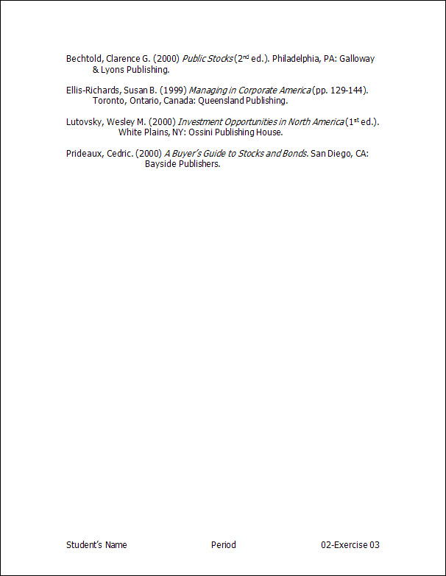
- Create a hanging indent of 1” in the 3rd paragraph.
- Hints:
  - Put the cursor in the 3rd paragraph.
      - Format Menu, Paragraph
        - Under Indentation
          - Special: Change to Hanging
          - By: Change to 1”
- Create a hanging indent of 1.5” in the 4th paragraph.
- Hints:
  - Put the cursor in the 4th paragraph.
      - Format Menu, Paragraph
        - Under Indentation
          - Special: Change to Hanging
          - By: Change to 1.5”
- Add a Blank (Three Column) Footer with your name, period, and “02-03”.
        - Change the font of the footer to 12-point Tahoma
- Save again and close the document.

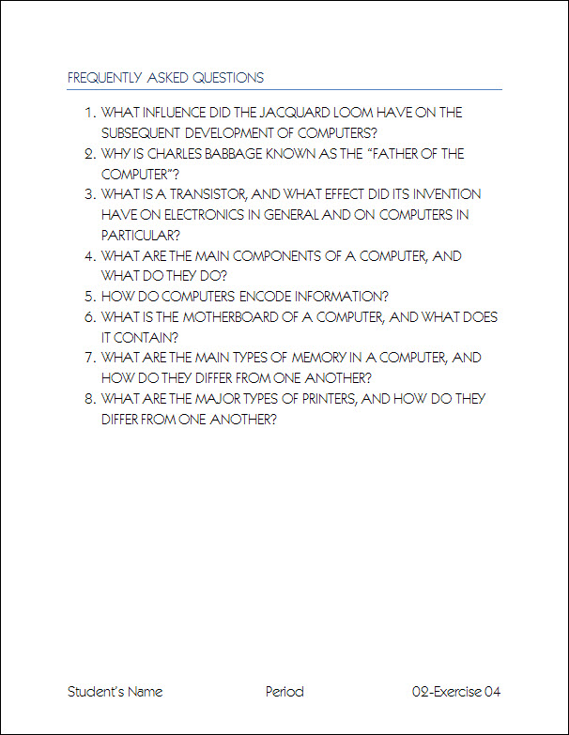
Exercise 04 {5 points}
- Open HandInOut\C-Nielsen\Hand-Out\CTech \02-Questions.
- Save as V:\CTech\Word\02-04.
- Change the style of the title “Frequently Asked Questions” to Title.
- Change the font to 16-point Noteworthy for the whole document.
- Change the text to UPPERCASE for the whole document.
- Number all the lines of text (except the title).
  - Hints:
    - Select the lines of text starting with “What influence..” and ending with “one another.”
    - Click the Numbering Button on the Home Tab, Paragraph Group
- Add Blank (Three Column) Footer with your name, period, and “02-04”.
  - Change the font of the footer to 16-point Noteworthy.
- Save again and close the document.

Exercise 05 {5 points}
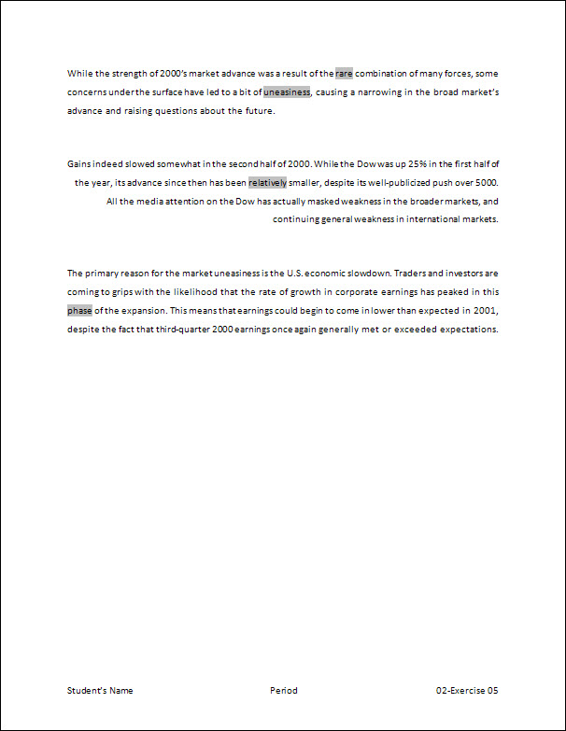
- Open HandInOut\C-Nielsen\Hand-Out\CTech \Word\02-Strength.
- Save as V:\CTech\Word\02-05.
- Change the horizontal () alignment of the 1st paragraph to justify.
- Change the horizontal () alignment of the 2nd paragraph to right.
- Change the horizontal () alignment of the 3rd paragraph to center.
- Add 18 points of spacing before and 18 points of spacing after the 2nd paragraph.
- Hints:
    - Put cursor in the 2nd paragraph.
      - On the Page Layout Tab, Paragraph Group, Spacing Section
        - Change Before to 18
        - Change After to 18.
- Add Blank (Three Column) Footer with your name, period, and “02-05”.
- Save again and close the document.

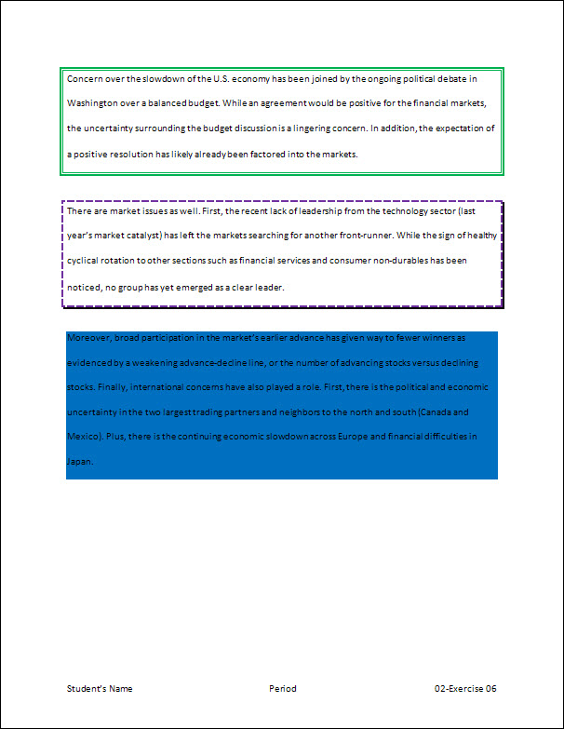
Exercise 06 {5 points}
- Open HandInOut\C-Nielsen\Hand-Out\CTech \Word\02-Concern.
- Save as V:\CTech\Word\02-06.
- Add a Green Thick/Thin box border to the 1st paragraph.
- Hints:
    - Put cursor in the 1st paragraph.
      - Format Menu
        - Click Borders and Shading
          - Make sure the Borders tab is Selected
            - Setting: Click Box
            - Style: Thick Thin
            - Color: Green
- Add a 3-point Purple Dashed shadow border to the 2nd paragraph.
- Hints:
    - Put cursor in the 2nd paragraph.
      - Format Menu
        - Click Borders and Shading
          - Make sure the Borders tab is Selected
            - Setting: Click Shadow
            - Style: Dashed
            - Color: Purple
            - Width: 3 point
- Add Blue Shading to the 3rd paragraph.
- Hints:
    - Put cursor in the 3rd paragraph.
      - Select the Format Menu
        - Click Borders and Shading
          - Make sure the Shading tab is selected
            - Fill: Blue
- Add 24 points of spacing before and after the 2nd paragraph.
- Add Blank (Three Column) Footer with your name, period, and “02-06”.
- Save again and close the document.

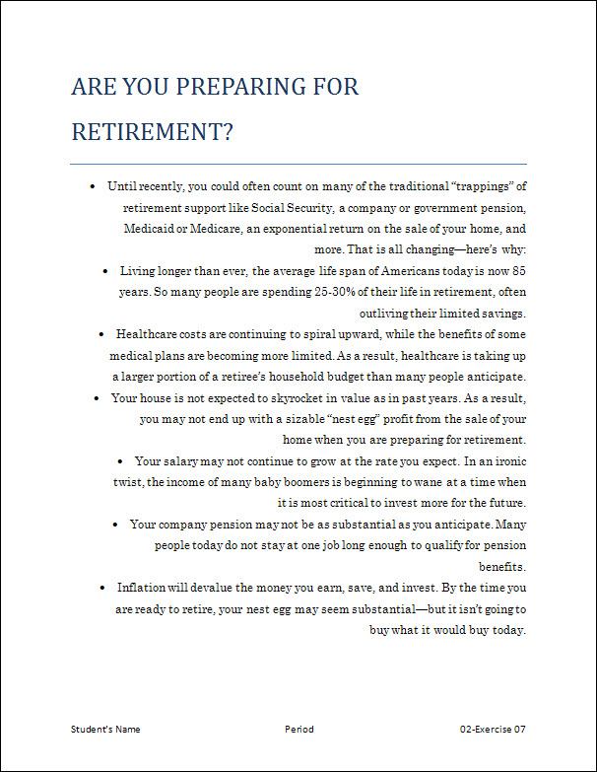
Exercise 07 {5 points}
- Open HandInOut\C-Nielsen\Hand-Out\CTech \Word\02-Preparing.
- Save as V:\CTech\Word\02-07.
- Change the style of the title “Are You Preparing for Retirement?” to Title.
- Change the line spacing for the whole document to 1.5.
  - Hints:
    - Select the whole document (Cmnd + A)
    - Press Cmnd + 5
- Add bullets of your choice to all text (except the title).
  - Hints:
    - Select the lines of text starting with “Until recently..” and ending with “would buy today.”
    - Click the Bullets Button on the Home Tab, Paragraph Group
      - Change the bullet if you choose.
- Change the horizontal () alignment of all the paragraphs to right.
- Add Blank (Three Column) Footer with your name, period, and “02-07”.
  - Change the font of the footer to 12-point Century Schoolbook
- Save again and close the document.

Exercise 08 {5 points}
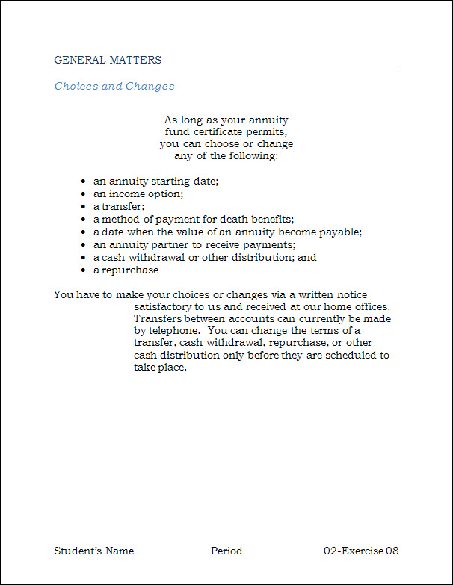
- Open HandInOut\C-Nielsen\Hand-Out\CTech \02-Matters.
- Save as V:\CTech\Word\02-08.
- Add bullets of your choice to the indented list.
  - Hints:
    - Select the lines of text starting with “an annuity..” and ending with “a repurchase.”
    - Click the Bullets Button on the Home Tab, Paragraph Group
      - Change the bullet if you choose.
- Create a left and right indent of 2” in the 1st paragraph.
- Change the horizontal () alignment of the 1st paragraph to center.
- Create a hanging indent of 1.5” in the last paragraph.
- Hints:
  - Put the cursor in the last paragraph.
      - Format Menu, Paragraph
        - Under Indentation
          - Special: Change to Hanging
          - By: Change to 1.5”
- Add Blank (Three Column) Footer with your name, period, and “02-08”.
  - Change the font of the footer to 14-point Bookman Old Style
- Save again and close the document.

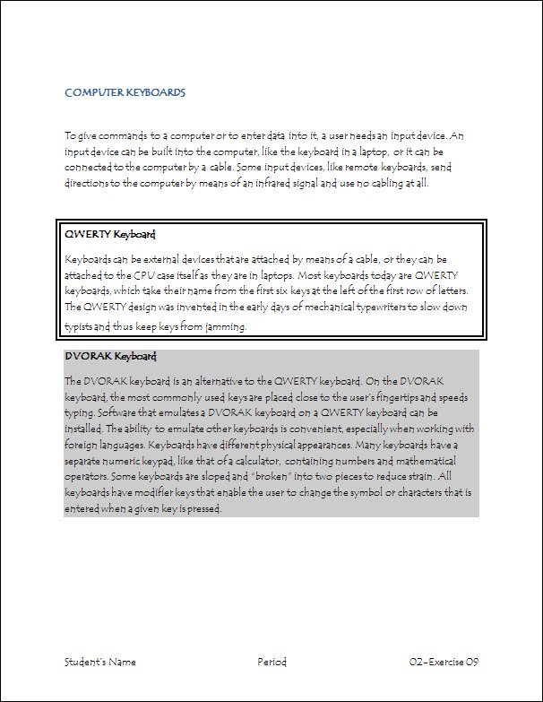
Exercise 09 {5 points}
- Open HandInOut\C-Nielsen\Hand-Out\CTech \Word\02-Keyboards.
- Save as V:\CTech\Word\02-09.
- Change the font to 12-point Papyrus for the whole document.
- Add 30 points of spacing before and after the 1st paragraph.
- Add a 3-point Double Line border to QWERTY Keyboard and its paragraph.
- Hints:
    - Select “QWERTY Keyboard” and its paragraph.
      - Click the Bottom Border arrow on the Home Tab, Paragraph Group
        - Click Borders and Shading
          - Make sure the Borders tab is selected
            - Setting: Click Box
            - Style: Double Line
            - Width: 3-point
- Add 20% shading to DVORAK Keyboard and its paragraph.
- Hints:
    - Select “DVORAK Keyboard” and its paragraph
      - Format Menu
        - Click Borders and Shading
          - Make sure the Shading tab is Selected
            - Style: 20%
- Add Blank (Three Column) Footer with your name, period, and “02-09”.
  - Change the font of the footer to 12-point Papyrus
- Save again and close the document.

Exercise 10 {5 points}
- Open HandInOut\C-Nielsen\Hand-Out\CTech \Word\02-Support.
- Save as V:\CTech\Word\02-10.
- Change the font to 20-point Santa Fe LET for the whole document.
- Change the horizontal () alignment of all the lines of text to right.
- Change the line spacing for the whole document to 2.0.
  - Hints:
    - Select the whole document
    - Press Cmnd + 2
- Change the text to tOGGLE cASE for the whole document.
- Add a Blank (Three Column) Footer with your name, period, and “02-10”.
  - Change the font of the footer to 20-point Santa Fe LET
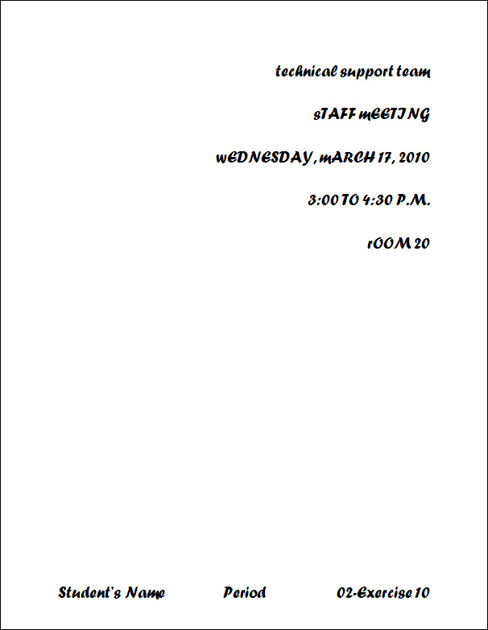
- Save again and close the document.

Turn all assignments into your folder in the Hand-In for your period.

