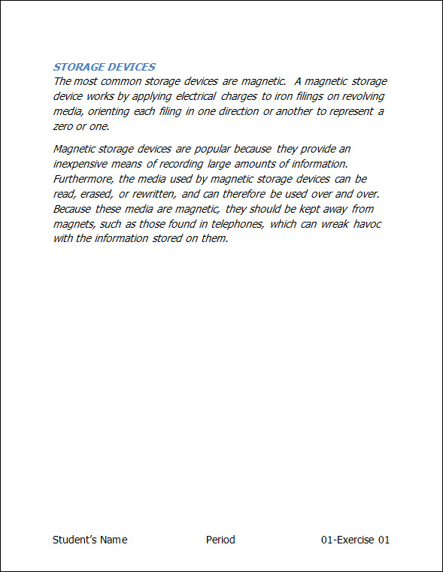
Exercise 01 {5 points}
- Open Student Common\C Nielsen\CTech\Word\01-Storage.
  - Hints:
    - Open the Student Common folder
    - Double Click on the C Nielsen Folder
    - Double Click on the CTech Folder
    - Double Click on the Word Folder
    - Click on the File “01-Storage”
    - Click OK
- Save as V:\C Tech\Word\01- Exercise 01.
  - Hints:
    - In the Filename Box type “V:”
    - Double Click on the C Tech folder
    - Double Click on the Word folder
    - In the Filename Box type “01-Exercise 1”
    - Click OK.
- Change the style of the title “Storage Devices” to Heading 2.
  - Hints:
    - Select the Title “Storage Devices”
      - Click Heading 2, on the Home Tab, Styles Group
- Change the font to Tahoma for the whole document.
  - Hints:
    - Select the whole document. (Ctrl + A)
    - Click the Font arrow, on the Home Tab, Font Group
      - Change to Tahoma
- Change the font size to 15-point for the whole document.
  - Hints:
    - Select the whole document. (Ctrl + A)
    - Click the Font Size arrow, on the Home Tab, Font Group
      - Type in “15”
- Change the font to Italic for the whole document.
  - Hints:
    - Select the whole document. (Ctrl + A)
    - Click the Italic button, on the Home Tab, Font Group
- Add a Blank (Three Column) Footer with your name, period, and “01-Exercise 01”.
  - Hints:
    - Click Footer, on the Insert Tab, Header & Footer Group
      - Click Blank (Three Columns).
        - Column 1- Click on [Type text] and Key Your First and Last Name
        - Column 2 – Click on [Type text] and Key Your Period
        - Column3 – Click on [Type text] and Key “01-Exercise 01”
      - Change the Font of the Footer to 15-point Tahoma
    - Click the Header & Footer Tools on the Title Bar
    - Click Close Header & Footer, on the Header & Footer Design, Close Group
- Save again, print, and close the document.
Exercise 02 {5 points}
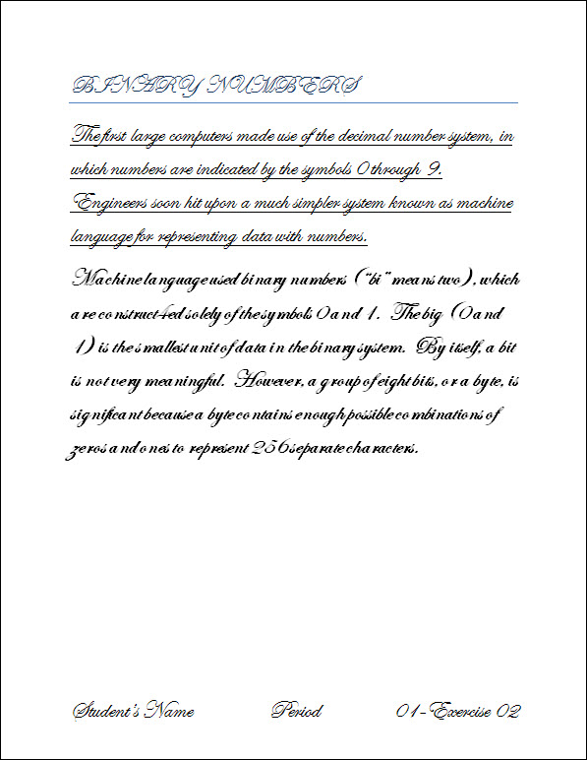
- Open Student Common\C Nielsen\CTech\Word\01-Binary.
  - Hints:
    - Open the Student Common folder
    - Double Click on the C Nielsen Folder
    - Double Click on the CTech Folder
    - Double Click on the Word Folder
    - Click on the File “01-Binary”
    - Click OK
- Save as V:\C Tech\Word\01-Exercise 02.
  - Hints:
    - In the Filename Box type “V:”
    - Double Click on the C Tech folder
    - Double Click on the Word folder
    - In the Filename Box type “01-Exercise 2”
    - Click OK.
- Change the font to Edwardian Script ITC for the whole document.
  - Hints:
    - Select the whole document. (Ctrl + A)
    - Click the Font arrow, on the Home Tab, Font Group
      - Change to Edwardian Script ITC
- Change the font size to 26-point for the whole document.
  - Hints:
    - Select the whole document. (Ctrl + A)
    - Click the Font Size arrow, on the Home Tab, Font Group
      - Type in “26”
- Change the font to Underline for the 1st paragraph.
  - Hints:
    - Select the 1st paragraph.
    - Click the Underline button, on the Home Tab, Font Group
- Change the font to Bold for the 2nd paragraph.
  - Hints:
    - Select the 2nd paragraph.
    - Click the Bold button, on the Home Tab, Font Group
- Add a Blank (Three Column) Footer with your name, period, and “01-Exercise 02”.
  - Hints:
    - Click Footer, on the Insert Tab, Header & Footer Group
      - Click Blank (Three Columns).
        - Column 1- Click on [Type text] and Key Your First and Last Name
        - Column 2 – Click on [Type text] and Key Your Period
        - Column3 – Click on [Type text] and Key “01-Exercise 02”
      - Change the Font of the Footer to 26-point Edwardian Script ITC
    - Click the Header & Footer Tools on the Title Bar
    - Click Close Header & Footer, on the Header & Footer Design, Close Group
- Save again, print, and close the document.
Exercise 03 {5 points}
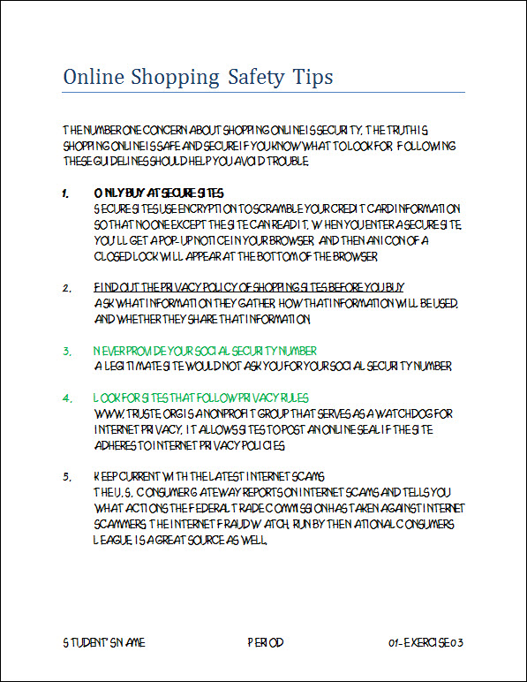
- Open Student Common\C Nielsen\CTech\Word\01-Online.
  - Hints:
    - Open the Student Common folder
    - Double Click on the C Nielsen Folder
    - Double Click on the CTech Folder
    - Double Click on the Word Folder
    - Click on the File “01-Online”
    - Click OK
- Save as V:\C Tech\Word\01-Exercise 3.
  - Hints:
    - In the Filename Box type “V:”
    - Double Click on the C Tech folder
    - Double Click on the Word folder
    - In the Filename Box type “01-Exercise 03”
    - Click OK
- Change the style of the title “Online Shopping Safety Tips” to Title.
  - Hints:
    - Select the Title “Storage Devices”
    - Click Title, on the Home Tab, Styles Group
- Bold the 1ST numbered heading.
  - Hints:
    - Select the text “ONLY BUY AT SECURE SITES.”
    - Click the Bold button on the Home Tab, Font Group
- Underline the 2nd numbered heading.
  - Hints:
    - Select the text “FIND OUT THE PRIVACY… BEFORE YOU BUY.”
    - Click the Underline button on the Home Tab, Font Group
- Change the font color to Green for the 3rd and 4th headings.
  - Hints:
    - Select the text “NEVER PROVIDE YOUR …. NUMBER.”
    - Click the Font Color arrow, on the Home Tab, Font Group
      - Click the Standard color Green
  - Hints:
    - Select the text “LOOK FOR SITES …. RULES.”
    - Click the Font Color arrow, on the Home Tab, Font Group
      - Click the Standard color Green
- Add a Blank (Three Column) Footer with your name, period, and 01-Exercise 03.
      - Change the Font of the Footer to 14-point Heavy Heap
- Save again, print, and close the document.
Exercise 04 {5 points}
- Open Student Common\C Nielsen\CTech\Word\01-Notice.
- Save as V:\C Tech\Word\01-Exercise 04.
- Change the font to 14-point Goudy Old Style for the whole document.
  - Hints:
    - Select the whole document. (Ctrl + A)
    - Change the Font to Goudy Old Style
    - Change the Font Size to 14
- Change the font color to Blue for the whole document.
  - Hints:
    - Select the whole document. (Ctrl + A)
    - Click the Font Color arrow, on the Home Tab, Font Group
      - Click the Standard color Blue
- Double Underline the text Annual Stockholder’s Meeting.
  - Hints:
    - Select the text Annual Stockholder’s Meeting.
    - Click the Underline arrow on the Home Tab, Font Group
      - Click the Double Underline
- Thick Underline the text 6:30 P.M.
  - Hints:
    - Select the text 6:30 p.m.
    - Click the Underline arrow on the Home Tab, Font Group
      - Click the Thick Underline
- Add a Blank (Three Column) Footer with your name, period, and 01-Exercise 04.
  - Change the font of the footer to 14-point Goudy Old Style
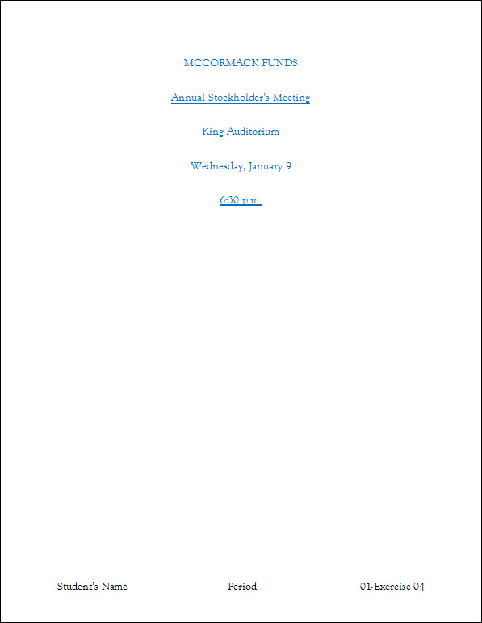
- Save again, print, and close the document.
Exercise 05 {5 points}
- Open Student Common\C Nielsen\CTech\Word\01-Abacus.
- Save as V:\C Tech\Word\01-Exercise 05.
- Change the style of the title “Chinese Abacus” to Title.
  - Hints:
    - Select the Title “Chinese Abacus”
      - Click Title, on the Home Tab, Styles Group
- Change your document to match the following paragraph.
  - Hint: You do not have to highlight…I did it to help you know what to change ;)
The Chinese abacus consisted of pebbles strung on rods inside a frame. The columns represented decimal places (ones place, tens place, hundreds place, and so on). Pebbles in the upper part of an abacus corresponded to 5 x 10⁰, or 5, for the first column; 5 x 10¹, or 50, for the second column; 5 x 10², or 500, for the third column; and so on. Pebbles in the lower part correspond to 1 x 10₀, or 1, for the first column; 1 x 10₁, or 10, for the second column; 1 x 10₂, or 100, for the third column; and so on.

  - Hints:
    - For the three (3) Superscript Numbers
      - Select the first number to superscript
        - Click Superscript on the Home Tab, Font Group (Press Ctrl + Shift + =)
      - Repeat for the remaining numbers
    - For the three (3) Subscript Numbers
      - Select the number
        - Click Subscript on the Home Tab, Font Group (Press Ctrl + =)
      - Repeat for the remaining numbers
- Change the font to 16-point Hurry Up for the whole document.
- Add a Blank (Three Column) Footer with your name, period, and “01-Exercise 05”.
  - Change the font of the footer to 16-point the Hurry Up.
- Save again, print, and close the document.
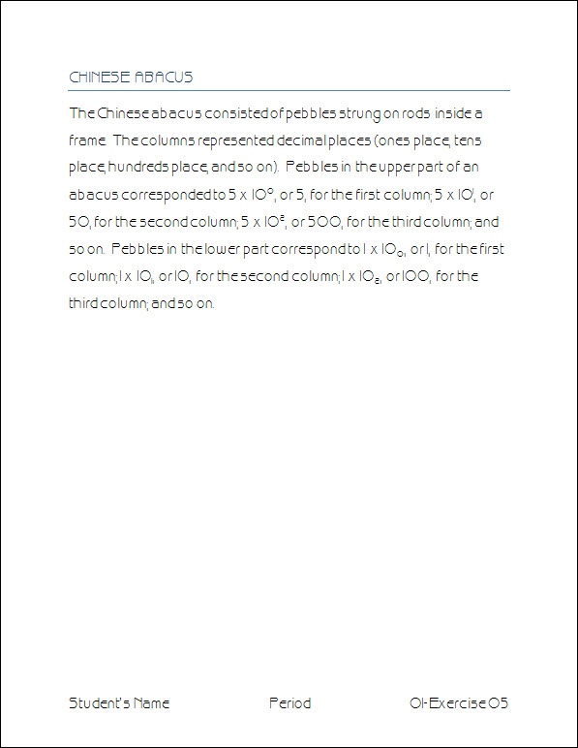
Exercise 06 {5 points}
- Open Student Common\C Nielsen\CTech\Word\01-Keyboards.
- Save as V:\C Tech\Word\01-Exercise 06.
- Change the font to 16-point Comic Sans MS for the whole document.
- Change the font color to the Standard Red for the whole document.
- Add a page break before the paragraph heading DVORAK Keyboard
  - Hints:
    - Put cursor in front of the D in DVORAK
    - Press Ctrl + Enter
- Add three symbols from Webdings to the end of the document.
  - Hints:
    - Press Ctrl + End
    - Click Symbol, on the Insert Tab, Symbols Group
      - Click More Symbols
      - Change Font to Webdings
        - Click on any symbol you choose
        - Click Insert
      - Repeat with two more symbols you choose
      - Click Close
- Add a Blank (Three Column) Footer with your name, period, and 01-Exercise 06.
  - Change the font of the footer to 16-point Comic Sans MS
- Save again, print, and close the document.
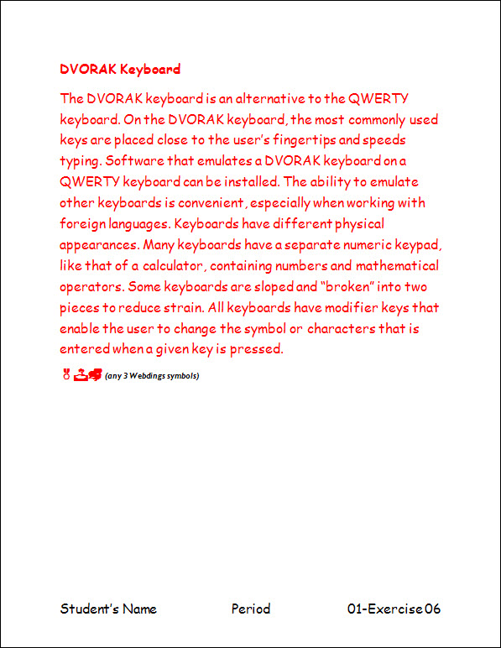
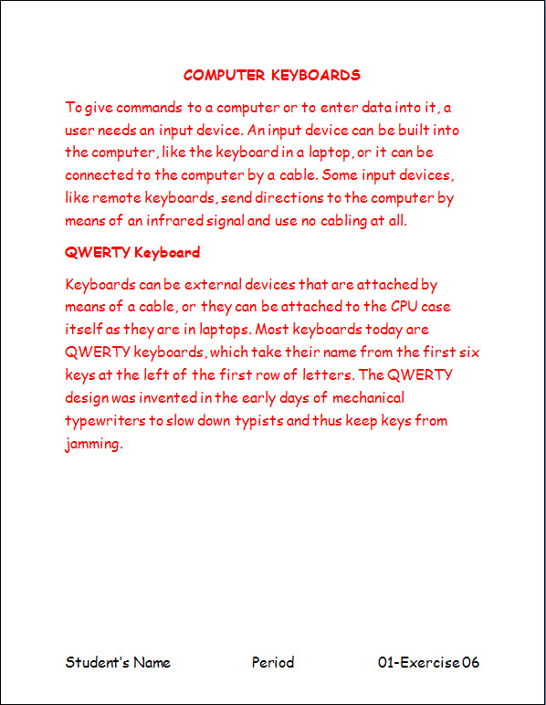
Exercise 07 {5 points}
- Open Student Common\C Nielsen\CTech\Word\01-Graphics.
- Save as V:\C Tech\Word\01-Exercise 07.
- Change the font to 12-point Garamond for the whole document.
- Change the case of the title “Graphics Software” to uppercase.
  - Hints:
    - Select the title “Graphics Software”
      - Click Change Case on the Home Tab, Font Group
        - Click Uppercase
- Change the case of the “Early Painting and Drawing Programs” heading and paragraph below to Capitalize Each Word.
  - Hints:
    - One page 1, select the heading “Early Painting and Drawing Programs” and the paragraph “In the early days … defined geometric shapes.”
      - Click Change Case on the Home Tab, Font Group
        - Click Capitalize Each Word
- Change the case of the “Painting and Drawing Programs Today” heading and the paragraph below to toggle case.
  - Hints:
    - One Page 2, select the heading “Painting and Drawing Programs Today” and paragraph “In the early days … sophisticated programs.”
      - Click Change Case on the Home Tab, Font Group
        - Click tOGGLE cASE
- Add a Blank (Three Column) Footer with your name, period, and 01-Exercise 07.
  - Change the font of the footer to 12-point Garamond
- Save again, print, and close the document.

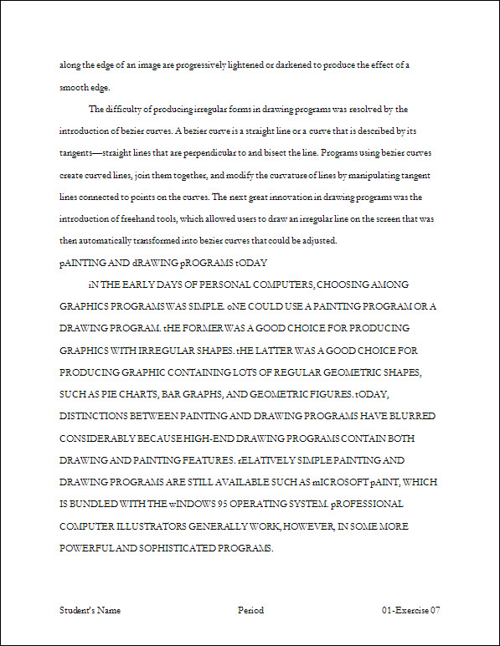
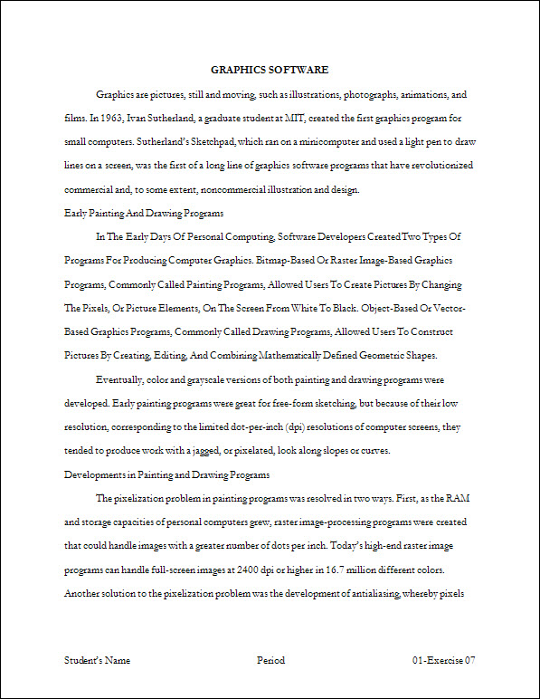
Exercise 08 {5 points}
- Open Student Common\C Nielsen\CTech\Word\01-Interface.
- Save as V:\C Tech\Word\01-Exercise 08.
- Change the style of the title “Natural Interface Applications” to Title.
- Change the style of the headings to Subtle Emphasis.
  - Hints:
    - Be sure to change all of the headings.
      - Speech Recognition
      - Natural-Language Interface
      - Virtual Reality
      - Mental Interface
- Change the font to 12-point Calisto MT for the whole document.
- Add a page break before the paragraph heading Virtual Reality Keyboard
  - Hints:
    - Put cursor in front of the V in Virtual Reality
    - Press Ctrl + Enter
- Add a Blank (Three Column) Footer with your name, period, and 01-Exercise 08.
  - Change the font of the footer to 12-point Calisto MT
- Save again, print, and close the document.

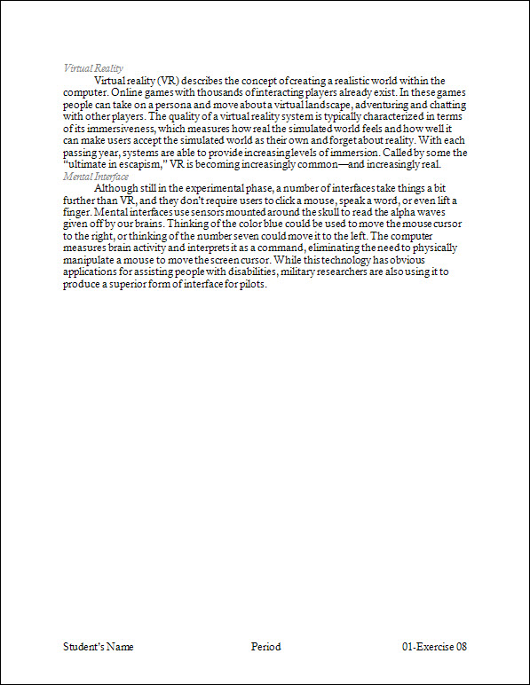
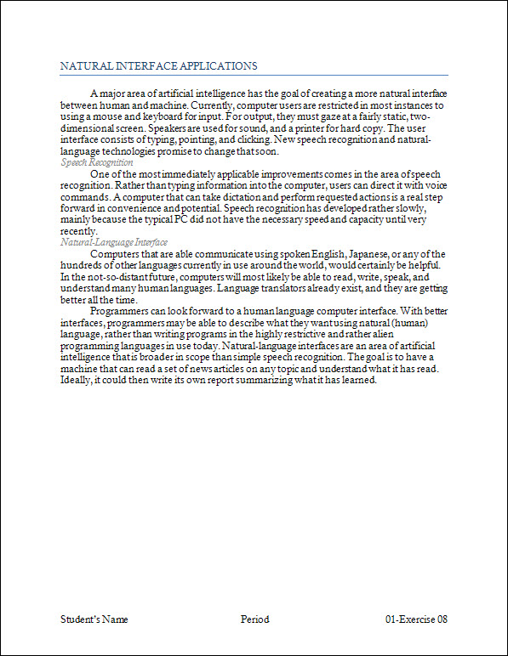
Exercise 09 {5 points}
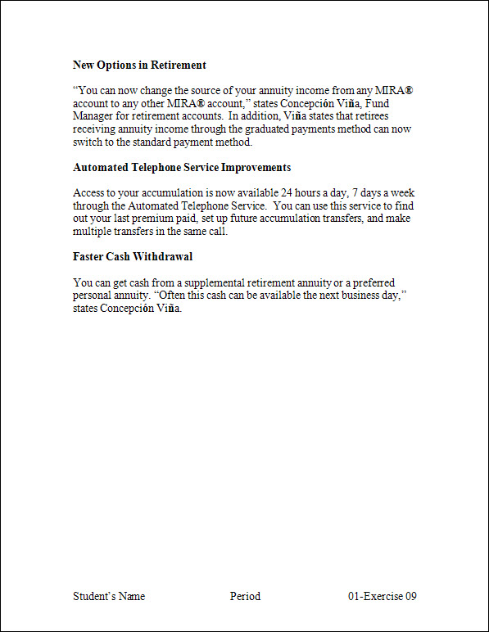
- Open Student Common\C Nielsen\CTech\Word\01-Retirement.
- Save as V:\C Tech\Word\01-Exercise 09.
- Bold all the paragraphs headings.
- At the grey boxes insert the symbols indicated below.
  - Hints:
    - At all occurrences of MIRA
      - Click Symbol, on the Insert Tab, Symbols Group
        - Click More Symbols
          - Change Font to (normal text)
            - Click the ® (Normal Text, 7th row, 14th column)
            - Click Insert
    - At all occurrences of Concepci n
      - Add the ó (Normal Text, 12th row, 3rd column)
    - At all occurrences of Vi a
      - Add the ñ (Normal Text, 12th row, 1st column)
- Add a Blank (Three Column) Footer with your name, period, and 01-Exercise 09.
  - Change the font of the footer to 14-point Times New Roman
- Save again, print, and close the document.

Exercise 10 {5 points}
- Open Student Common\C Nielsen\CTech\Word\01-Timeline.
- Save as V:\C Tech\Word\01-Exercise 10.
- Change the font to Broadway for the whole document.
- Change the case of all the text in item #1 to toggle case.
- Change the case of all the text in item #3 to UPPERCASE.
- Change the case of all the text in item #5 to lowercase.
- Add a Blank (Three Column) Footer with your name, period, and 01-Exercise 10.
  - Change the font of the footer to 14-point Broadway
- Save again, print, and close the document.

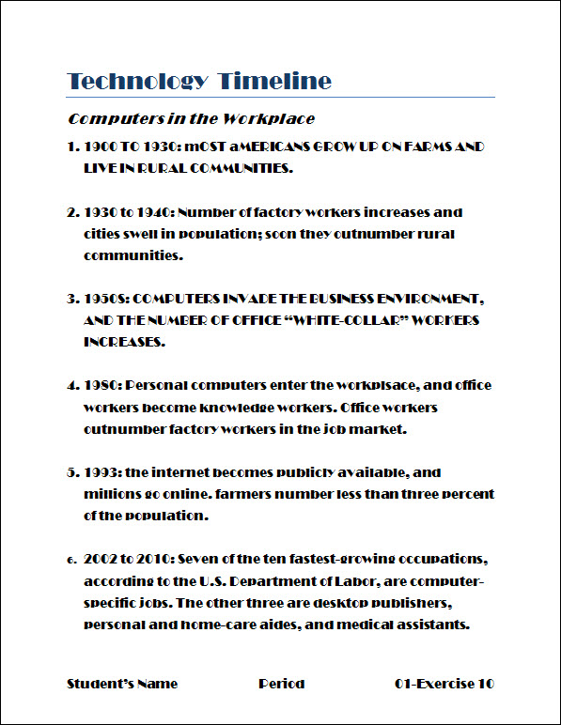

Put all printout in order, staple with half sheet, turn into the basket.

