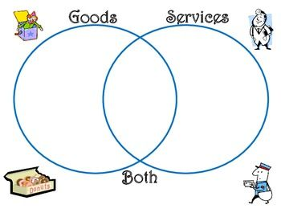
Choose a business in the hospitality sector. Come up with 10 products the company offers. Place the products in the above diagram using text boxes. Justify why it is a Good, Service or Both below. You may do this in partners, (but you must submit it as a group, and add yourself to a group on canvas)
Product | Justification

