Photo Editing #1
- Open Internet Explorer and go to www.picnik.com
- Upload the RedEye1 photo.
  - Click the Photo Tab
  - Click Get from Computer
    - Go to Computer\My Documents
    - Select the picture and click Upload
- Fix the red eye.
  - Under the Edit Tab, Touch-Up
- Rotate the image
  - Under the Edit tab, Basic Edits, Rotate
- Resize the image
  - Under the Edit tab, Basic Edits, Resize
- Change the colors of the picture
  - Under the Edit tab, Basic Edits, Colors
  - Use the Saturation and Temperature sliders to improve the color of the picture
    - Do not make the tones unnatural
- Save your photo
  - Click on the Save & Share tab
  - Make sure Save to Computer is selected
  - Change the file name to: yourname_RedEye1
  - Save to your student drive
- Print your photo on the color printer.
Photo Editing #2
- Open Internet Explorer and go to www.picnik.com
- Choose one of the animal photos in Student Common\C Nielsen\CTE Intro\Photo Editing. (Dog&Cat, Eating, GiraffeUpClose, or MadBird)
- Upload the photo you chose.
  - Click the Photo Tab
  - Click Get from Computer
    - Go to Computer\My Documents
    - Select the picture and click upload
- Add a funny saying to the picture
  - Use the Text feature, under the Edit tab
- Do two of the following:
  - Change the color of the picture to be crazy
  - Add an Effect to the picture (Sepia, Fade, Boost, Black & White…)
  - Add a sticker
  - Use a seasonal effect
  - Crop the picture
  - Change the exposure
- Add a frame to your photo
  - Under the Edit tab, Frames
- Save your photo
  - Click on the Save & Share tab
  - Make sure Save to Computer is selected
  - Change the file name to: yourname_animal
  - Save to your student drive
- Print your photo on the color printer.

Photo Editing #3

- Open Internet Explorer and go to www.picnik.com
- Open a photo from the internet
  - Use Yahoo!, Google, or Bing image search to find an image.
  - Use the SAFESEARCH option.
  - Enter the topic you want to search and click search.
  - Save the photo to your computer
- Upload photo to Picnik.
- Make three changes to the photo
  - Crop
  - Rotate
  - Add text
  - Add an effect (sepia, black & white, etc.)
  - Improve or change the colors
  - Touch-Up
  - Add stickers
  - Add a frame
- Save your photo
  - Click on the Save & Share tab
  - Make sure Save to Computer is selected
  - Change the file name to: yourname_photo3
  - Save to your student drive
- Print your photo on the color printer.

Photo Editing #4

- Take a digital photo of a person or group of people and upload it to Picnik.com
- Using Picnik's editing features perform at least two editing functions (crop the photo, remove redeye, etc.)
- Make three other changes to the photo
  - Add text
  - Add stickers
  - Add an effect (sepia, black & white, etc.)
  - Use a touch-up (teeth whitening, etc.)
  - Add a frame to your photo.
  - Add seasonal effects to your photo.
- When you are finished with the changes, go to Frames (Edit=>Frames) and add the "Before & After" Frame to your picture.
- Save your photo
  - Click on the Save & Share tab
  - Make sure Save to Computer is selected
  - Change the file name to: yourname_photo4
  - Save to your student drive
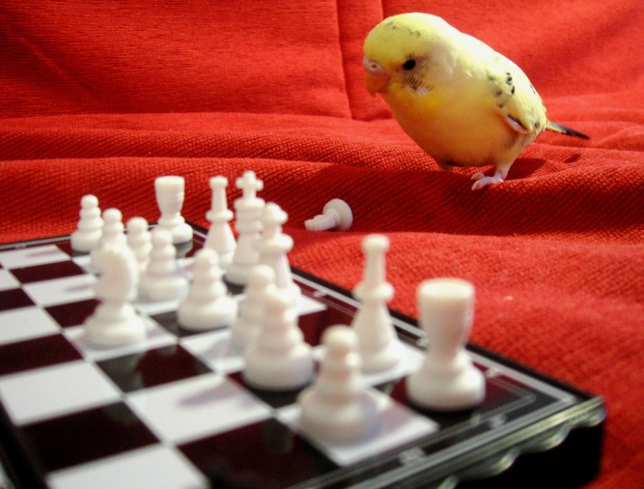
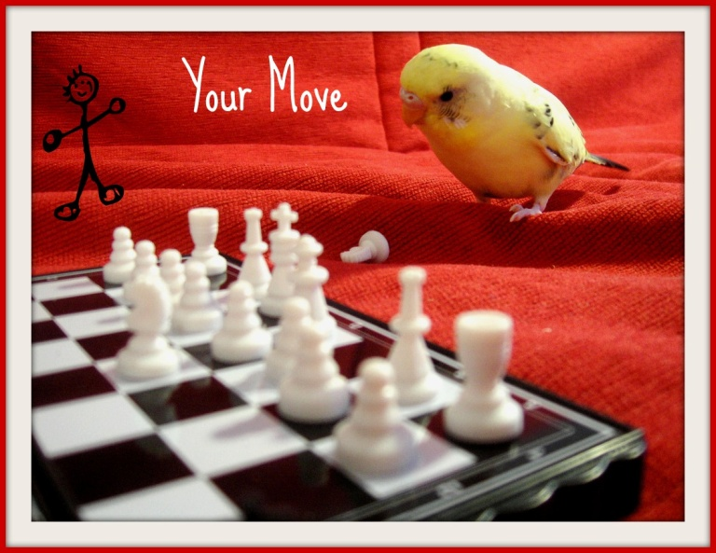
- Print your photo on the color printer.
Before
After

Once you have all printouts staple them together, put your Name on them and put them in the basket.
Before

