Follow to learn Excel Chapter 1
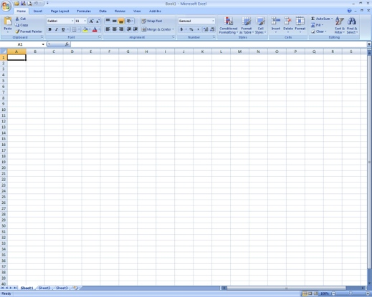
- Double click on the Excel icon
  - Displays
    - Title Bar
    - File
    - Quick Access Toolbar
    - Tabs
    - Work Sheet (s)
    - Name Box / Formula Bar
    - Columns – labeled by letter
    - Rows – labeled by number
    - Cells – labeled by letter than number (F6)

- Entering Data
  - Click in cell A1
    - Type “Computer Technology”
      - Notice the text is longer than the cell
        - Don’t worry about it for now
  - Press Tab key to move to Cell B1
  - Press Tab key to move to Cell C1
    - Type your Favorite Ice Cream Flavor
  - Press Enter to move to Cell A2
- Auto Fill – automatically inserts words, numbers or formulas in a series
  - Predefined Patterns
    - In cell A2
      - Type “Monday”
        - With mouse point at the bottom right corner of cell A2 get the fill handle (plus sign)
          - Click the left mouse button and hold
            - Drag left until you see Friday in cell E2
    - Go to Cell A3
      - Type January
        - Fill left until you get to May
  - Creating a Pattern
    - Go to Cell A4 and Type 20
    - Go to Cell A5 and Type 30
    - Select cells A4 and A5
      - Fill down until you get to 50
    - Create another number pattern from B4 to B8

- Auto Correct – automatically corrects common typing mistakes
  - Go to Cell A9
    - Type “acn”
      - What happened to the text?
  - Press Tab twice to move to Cell C9
  - Press Shift + Tab to move back to Cell B9
    - Type “(tm)”
      - What happened to the text?
  - Press Enter

- AutoComplete – automatically inserts data in a cell that begins the same as previous entry
  - Click in cell A6
    - Type AMS
  - Press Enter to move to Cell A7
    - Type A
      - What happened?
      - Press Down Arrow, then Enter to accept AMS
  - This only works in the same column

- Selecting - lets you highlight the cells that need to be changed
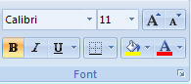
  - Rows
    - Select all of Row 2 by clicking on the row number 2
      - Click the Bold on the Home Tab, Font Group (Press Cmnd + B)
  - Columns
    - Select all of Column C by clicking the column letter C
      - Click Italic on the Home Tab, Font Group (Press Cmnd + I)
  - Cells
    - Click in Cell A3 and drag to Cell E3
      - Click Underline on the Home Tab, Font Group (Press Cmnd + U)
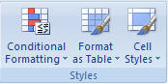
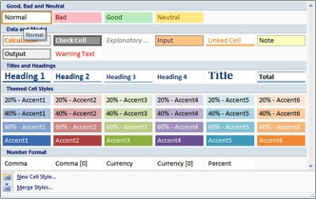
- Cell Styles – predesigned formatting options
  - Select cells A1 through E1
    - Click Cell Styles on the Home Tab, Format Group
      - Under Titles and Headings, Click Heading 1
  - Select cells A6 through A7
    - Click Cell Styles on the Home Tab, Format Group
      - Under Data and Model, Click Note
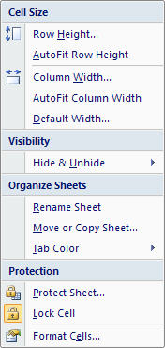
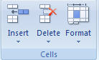
- Auto Fit Column Width – adjusts the size of the column from left to right
  - Select cells A1 through E11
    - Click Format, on the Home Tab, Cells Group
      - Under Format, Click AutoFit Column Width

- Name Requirement
  - Click in Cell A9
    - Type your First and Last Name
  - Click in Cell A10
    - Type “01-Lesson”

- Save as “01-Lesson” in your student drive under the excel folder.

- Print Preview – allows you to check the appearance of the whole spreadsheet before printing
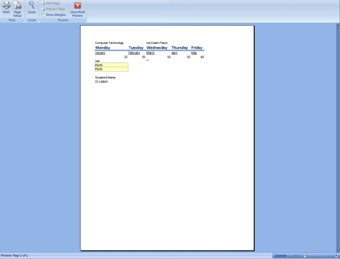
  - Click Print Preview on the Quick Access Toolbar
    - Check to make sure the spreadsheet is only 1 page (bottom left)
      - If only 1 page you are ok to print
        - Click Print
      - If more than 1 page you need to get help determining why

Close the spreadsheet (Press Cmnd + W)
