Follow to learn File Management
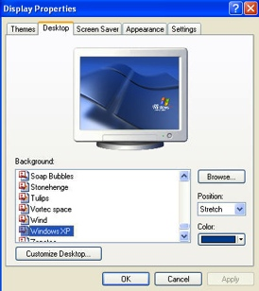
- Control Panel – allows you to change the appearance of your desktop
  - Desktop – the backgrounds that you see on your monitor
    - Right Click anywhere on the Desktop, Click Properties
      - Click the Desktop Tab
        - Background: Change to Soap Bubbles
          - Position: Change to Stretch
            - Click Apply
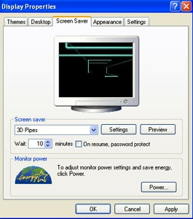
          - Position: Change to Tile
            - Click Apply
  - Screen Saver – lets you monitor rest when the computer is inactive.
    - Change the tab to Screen Saver
      - Screen Saver: Change to Beziers
        - Wait: Click the down arrow to 1 minute
          - The arrows are Spin Boxes
        - Click Preview (allows you to see the screen saver without waiting)
          - Press the space bar to return to the desktop
            - Click Apply
  - Resolution – changes the viewing size and clarity of your monitor (higher means small and more clear)
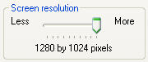
    - Change the tab to Settings
      - Slide Screen Resolution to Less
        - Click the Advanced Button
          - Notice the After I change display settings
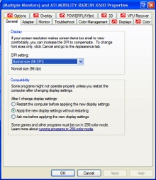
            - Makes sure the radio is in “Apply the new display settings without restarting”
            - These are Radio Buttons
              - Click Ok
        - Click Apply
          - On the Monitor Warning, Click No
      - Click Cancel to get out of the Display Properties dialog box

- My Computer
  - Double Click on My Computer (upper left corner of monitor)
    - A dialog box appears (boxes that come up that ask for user input or share information)
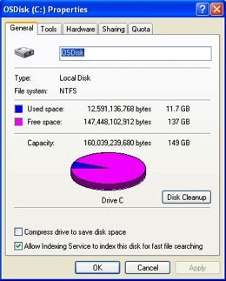
  - Properties – let you see how much of your space is used and free.
    - Point at the Hard Drive Disks (C:) and Right Click then Click Properties
      - Tabs in the dialog box allow you to work with different subjects
        - At the General Tab
          - Notice the used and free space
          - Click “Compress drive to save disk space”
            - This is a Check box
              - Click Cancel
  - Deleting files from the hard drive sends the files to the Recycle Bin

- Drives and Folders
  - Drives – containers on a computer or network used for storing data
    - Student Network Drive = My Documents on the Albion Middle School Network
      - Click Start, then Computer, then Right Click on My Documents and Click Properties
        - Notice your used and free space
          - Click Cancel
      - Double Click on My Documents
        - You should have some files from Computer Technology
        - You may have some folders or files from other classes
    - Shared Network Drive = Teacher Hand-In/Out
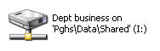
      - Double click on the Hand In/Out
My Documents
Network Drive
          - Double click on the C-Nielsen\Hand-Out\CTech
          - Double click on the Word folder
    - You should have two dialog boxes open (My Docs & Hand-Out\CTech)
      - Switch to My Documents
  - Folders – containers on a computer or network drive used for organizing data
    - Creating Folders
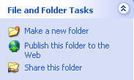
      - Click “Make a new folder” on the left side of the dialog box
        - In the Folder Box that says New Folder type your “First and Last Name”
          - Press Enter to accept the new name
          - Double Click on your name folder
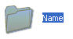
            - Inside there should be no files
Folder
            - Click Back to return the My Documents
      - Create another new folder called “Drills” in My Documents
    - Moving files into a Folder
      - Drag and Drop
        - Click on Drill 1 and hold down the left mouse button
        - Drag Drill 1 until it appears to be on top of the Drills Folder
        - Release the left mouse button
      - Repeat Drag and Drop for all the remaining Drills
    - Switch to the Hand-Out
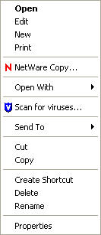
- Copying and Pasting Files – lets you put a duplicate of a file in another location
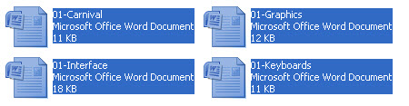
  - Consecutive Files (next to each other)
    - Click the file “01-Carnival”
    - Hold down the Shift key on the keyboard
    - Click the file “01-Keyboards”
    - Right click on any of the selected filenames and Click Copy
      - This is a Drop Down Menu
    - Switch to My Documents
    - Right click in the white space and Click Paste
  - Non-Consecutive Files (files not next to each other)
    - Switch to the Hand-Out and change to the Excel Folder
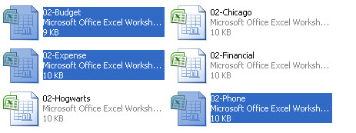
    - Click the file “02-Budget”
    - Hold down the Ctrl key on the keyboard
    - Click the file “02-Expense”
    - Click the file “02-Phone”
    - Right click on any of the selected filenames and Click Copy
    - Switch to My Documents
    - Right click in the white space and Click Paste

- Cutting and Pasting Files – let you put a file in a different location
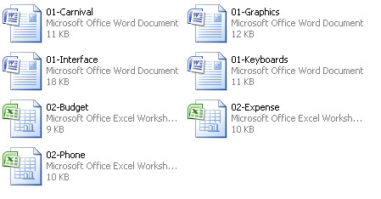
  - Select all the files in My Documents (see diagram)
  - Right Click and select Cut
  - Double click on your name folder
  - Right click in the white space and Click Paste

- Renaming Files – changes the name of the files
  - Select “01-Keyboards” – do not open (Single click)
    - Press F2
    - Type “CC-1” and Press Enter
  - Select “01-Graphics” and rename “CC-2”
  - Select “02-Budget” – do not open
    - Right click on the filename and Click Rename
    - Type “CC-3” and Press Enter
  - Select “02-Phone” and rename “CC-4”

- Deleting Files – will be gone, the recycle bin is not used when deleting on anything by the Hard Drive
  - Select the three non- “CC” files – do not open
    - Right Click on the file name and go down to Delete
      - When asked if you really want to delete Click Yes

- Refreshing Lists – Allows you to update and to see any changes that don’t show up immediately.
  - Press F5

- Close both the My Documents and Hand-Out windows.

