Follow to learn Excel Chapter 1
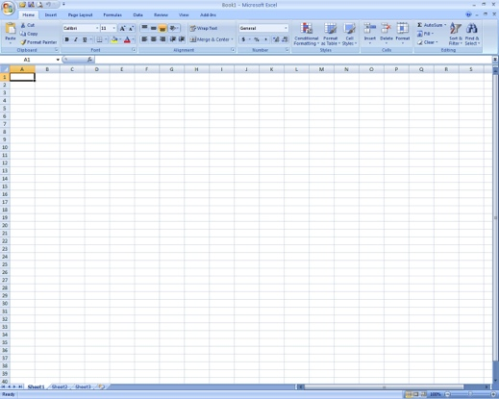
- Double click on the Excel icon
  - Displays
    - Title Bar
    - File
    - Quick Access Toolbar
    - Tabs
    - Work Sheet (s)
    - Name Box / Formula Bar
    - Columns – labeled by letter
    - Rows – labeled by number
    - Cells – labeled by letter than number (F6)

- Entering Data
  - Click in cell A1
    - Type “Computer Technology”
      - Notice the text is longer than the cell
        - Don’t worry about it for now
  - Press Tab key to move to Cell B1
  - Press Tab key to move to Cell C1
    - Type your Favorite Ice Cream Flavor
  - Press Enter to move to Cell A2
- Auto Fill – automatically inserts words, numbers or formulas in a series
  - Predefined Patterns
    - In cell A2
      - Type “Monday”
        - With mouse point at the bottom right corner of cell A2 get the fill handle (plus sign)
          - Click the left mouse button and hold
            - Drag right until you see Friday in cell E2
    - Go to Cell A3
      - Type January
        - Fill right until you get to May
  - Creating a Pattern
    - Go to Cell A4 and Type 20
    - Go to Cell B4 and Type 30
    - Select cells A4 and B4
      - Fill right until you get to 50
  - Create your own pattern
    - Go to Cell A5 and Type a number
    - Go to Cell B5 and Type another number
      - Fill right until you get to E5

- Auto Correct – automatically corrects common typing mistakes
  - Go to Cell A6
    - Type “acn”
      - What happened to the text?
  - Press Tab twice to move to Cell C5
  - Press Shift + Tab to move back to Cell B5
    - Type (tm)
      - What happened to the text?
  - Press Enter

- AutoComplete – automatically inserts data in a cell that begins the same as previous entry
  - Click in cell A7
    - Type AMS
    - Press Enter to move to Cell A8
    - Type A
      - What happened?
      - Press Enter to accept AMS
  - This only works in the same column

- Selecting - lets you highlight the cells that need to be changed
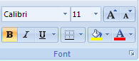
  - Rows
    - Select all of Row 2 by clicking on the row number 2
      - Click the Bold on the Home Tab, Font Group (Press Ctrl + B)
  - Columns
    - Select all of Column C by clicking the column letter C
      - Click Italic on the Home Tab, Font Group (Press Ctrl + I)
  - Cells
    - Click in Cell A3 and drag to Cell E3
      - Click Underline on the Home Tab, Font Group (Press Ctrl + U)
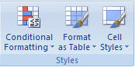
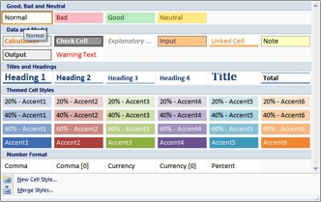
- Cell Styles – predesigned formatting options
  - Select cells A3 through E3
    - Click Cell Styles on the Home Tab, Styles Group
      - Under Titles and Headings, Click Heading 1
  - Select cells A7 through A8
    - Click Cell Styles on the Home Tab, Styles Group
      - Under Data and Model, Click Note
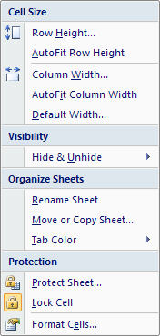
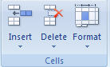
- Auto Fit Column Width – adjusts the size of the column from left to right
  - Select cells A1 through E7
    - Click Format, on the Home Tab, Cells Group
      - Under Cell Size, Click AutoFit Column Width

- Name Requirement
  - Click in Cell A9
    - Type your First and Last Name
  - Click in Cell A10
    - Type “1-Lesson”

- Save as “1-Lesson” in your My Documents\CTech\Excel folder.

- Print Preview – allows you to check the appearance of the whole spreadsheet before printing
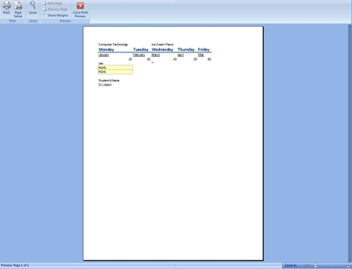
  - Click File, Print
    - Check to make sure the spreadsheet is only 1 page (bottom center)
      - If only 1 page you are ok to print
        - Click Print
      - If more than 1 page you need to get help determining why

Close the spreadsheet (Press Ctrl + F4)
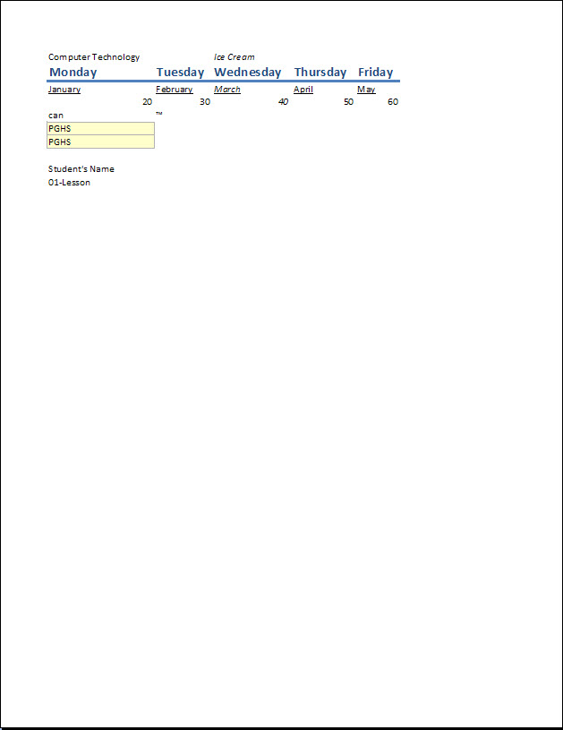
s

