Desktop Publishing

Create **1 bumper sticker**, **2 different flyers or posters,** and **1 Game Board.**

You may create a 3rd flyerand an extra game board for extra credit.

**Bumper Sticker Criteria:**

1. At least **1 Graphic/Picture**
2. At least **1 Line of Text** (that you come up with)
3. **Name** and **Period**

**Flyer Criteria:**

1. Put your **name** and **period** on the top or bottom of each flyer.
2. Place the **name of the product/event & a slogan/saying** on the flyer.
3. Use at least **2 different font colors** (color of the words) **or WordArt**.
   1. Home tab, Font Color, WordArt is on the Insert Menu
4. At least **1 graphic**
5. Add anything else that’s important on a flyer
   1. For example: Business address, phone number, website, time and place, etc.
6. Save each flyer on your student drive (Your My Documents)
7. Print.

**Examples:**

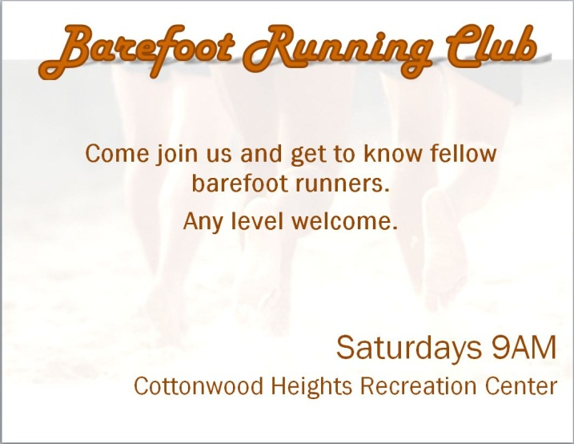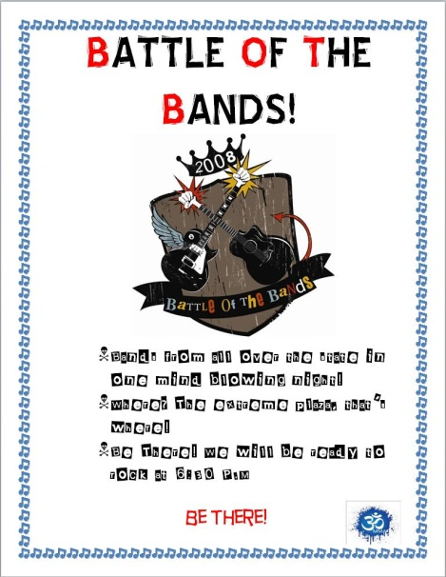

**Make Your Own Game Board**

1. Start your game with a simple shape.
   1. On the home ribbon choose the “Shapes” menu. (Pick any shape you want.)
2. Format your shape!
   1. Click on the shape, and go to the Format Ribbon. (At the top of the screen, it’s Purple)
   2. Pick one of the preformatted styles or change the shape fill and outline to create your own.
3. Copy and paste the shape and drag the copy next to the original shape to create a path for your tokens to follow on your game board.
   1. Repeat this as many times as you need to in order to create a path that **fills up your page.**
4. Change the colors of a lot of the squares to create a more colorful pattern for your game board.
5. Add text to some of the squares (Double Click on your shape) to create challenges for the game players.
   1. For Example: Move back two spaces, Lose a turn, Jump ahead three spaces, Move forward to the nearest purple space, etc.
6. C:\Users\Dad\AppData\Local\Microsoft\Windows\Temporary Internet Files\Content.IE5\D96S91UD\MC900001600[1].wmfAdd a minimum of **three** graphics to your game board and choose a theme. Every good game has a theme!! (Think…Chutes & Ladders, Candyland, etc.)

**Move forward 2 spaces**

**Move back 2 spaces**

Start

C:\Users\Dad\AppData\Local\Microsoft\Windows\Temporary Internet Files\Content.IE5\3YIH6RHV\MC900417472[1].wmf

END

**Move back 2 spaces**

***Put all printouts together (2 flyers and game board), staple, and put in the basket.***