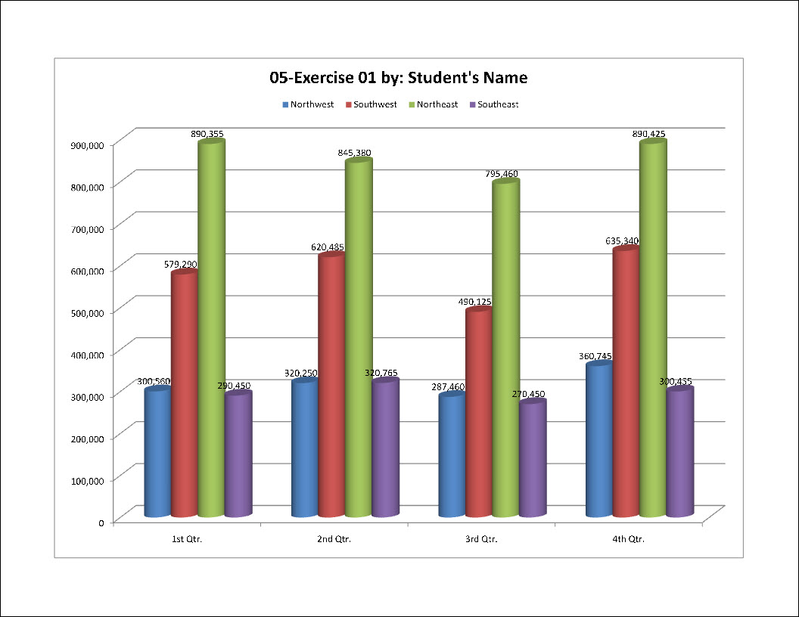
Exercise 1 {5 points}
- Open HandInOut\C-Nielsen\Hand-Out\CTech\Excel\05-Region.
- Save as My Documents\CTech\Excel\5-1.
- Create a Clustered Cylinder Column chart for the data in cells A1 through E5.
  - Hints:
    - Select cells A1 through E5
      - Click Column on the Insert Tab, Charts Group
        - Click Clustered Cylinder under Cylinder
- Move the chart location to a new sheet.
  - Hints:
    - Click on the chart to select it
      - Click Move Chart on the Chart Tools Design Tab, Location Group
        - Click New Sheet
          - Click Ok
- Show the legend at the top of the chart.
  - Hints:
    - Click Legend on the Chart Tools Layout Tab, Labels Group
      - Click Show Legend at Top
- Show the data labels for all the cylinders.
  - Hints:
    - Click Data Labels on the Chart Tools Layout Tab, Labels Group
      - Click Show
- Add a Chart Title above chart with “5-1 by: Your Name”.
  - Hints:
    - Click Chart Title on the Chart Tools Layout Tab, Labels Group
      - Click Above Chart
        - Click in the Chart Title Box
          - Delete Chart Title
            - Type “4-1 by: Your Name”
- Add Line Sparkline to the column after the data. (Chart Tab, Sparkline Group)
- In the Sparkline design tab, change the Vertical Axis Minimum Value to “Same for All Sparklines.”
- Change the font of the chart title and legend.
- Save again and close the worksheet.
Exercise 2 {5 points}
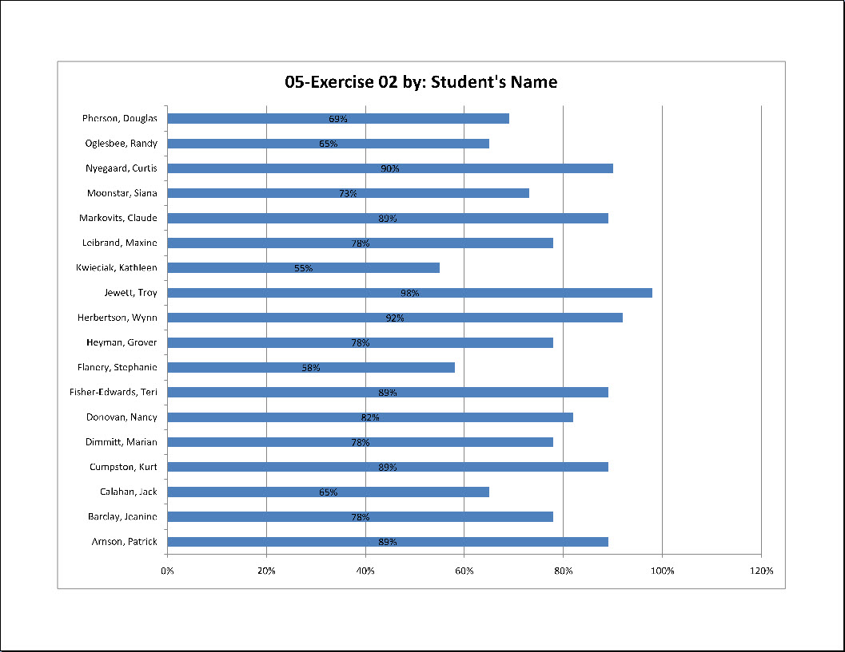
- Open HandInOut\C-Nielsen\Hand-Out\CTech\Excel\05-Test.
- Save as My Documents\CTech\Excel\5-2.
- Create a Stacked Bar chart for the data in cells A2 through B19.
  - Hints:
    - Select cells A2 through B19
      - Click Bar on the Insert Tab, Charts Group
        - Click Stacked Bar under 2-D Bar
- Move the chart location to a new sheet.
  - Hints:
    - Click on the chart to select it
      - Click Move Chart on the Chart Tools Design Tab, Location Group
        - Click New Sheet
          - Click Ok
- Remove the legend from the chart.
  - Hints:
    - Click Legend on the Chart Tools Layout Tab, Labels Group
      - Click None
- Change the color of the data bars.
- Show centered data labels for all the bars.
  - Hints:
    - Click Data Labels on the Chart Tools Layout Tab, Labels Group
      - Click Center
- Add a Chart Title above chart with “5-2 by: Your Name”.
  - Hints:
    - Click Chart Title on the Chart Tools Layout Tab, Labels Group
      - Click Above Chart
        - Click in the Chart Title Box
          - Delete Chart Title
            - Type “5-2 by: Your Name”
- Change the font and font color for the title, axes, and data labels.
- Save again and close the worksheet.
Exercise 3 {5 points}
- Open HandInOut\C-Nielsen\Hand-Out\CTech\Excel\05-Sales.
- Save as My Documents\CTech\Excel\5-3.
- Switch the data for the chart.
  - Hints:
    - Click Switch Row/Column on the Chart Tools Design Tab, Data Group
- Show the inside end data labels for all segments.
  - Hints:
    - Click Data Labels on the Chart Tools Layout Tab, Labels Group
      - Click Inside End
- Move the legend to the left of the chart.
  - Hints:
    - Click Legend on the Chart Tools Layout Tab, Labels Group
      - Click Show Legend at Left
- Change the font of the Legend to 14-point font of your choice.
  - Hints:
    - Click on the legend to select it
      - Change the font on the Home Tab
- Change the font of the Data Labels to 14-point matching font.
  - Hints:
    - Click on any data label to select them all
      - Change the font to 14-point Kids
- Add a Chart Title above chart with “5-3 by: Your Name”.
- Change the font of the Chart Title to 14-point matching font.
  - Hints:
    - Select “3 by: Your Name”
      - Change the font to 14-point Kristen ITC
- Add a Line Sparkline to the column after the data.
- In the Sparkline design tab, change the Vertical Axis Minimum Value to “Same for All Sparklines.”
- Change the style of the Sparklines. (Sparklines Tab)
- Change the font of the table so it matches the chart (14-point).
- Autofit Column Width.
- Save again and close the worksheet.
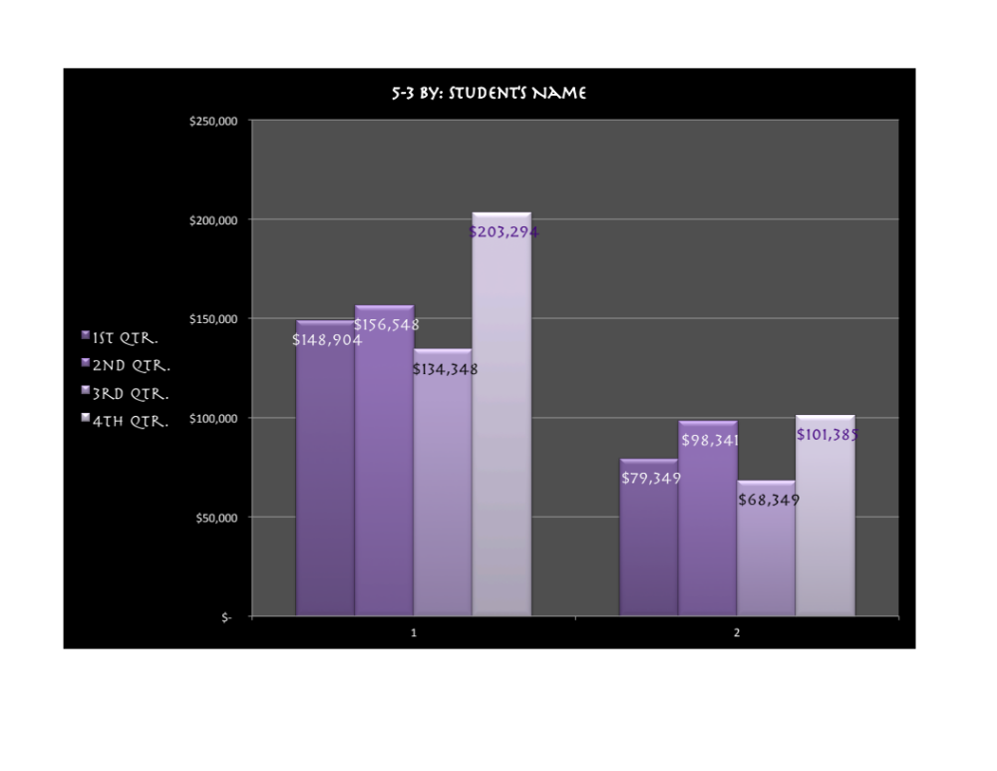
Exercise 4 {5 points}
- Open HandInOut\C-Nielsen\Hand-Out\CTech\Excel\05-Public.
- Save as My Documents\CTech\Excel\5-4.
- Create a 2-D Area chart for the data in cells A4 through B10.
- Move the chart location to a new sheet.
- Show the data labels for all categories.
- Remove the legend from the chart.
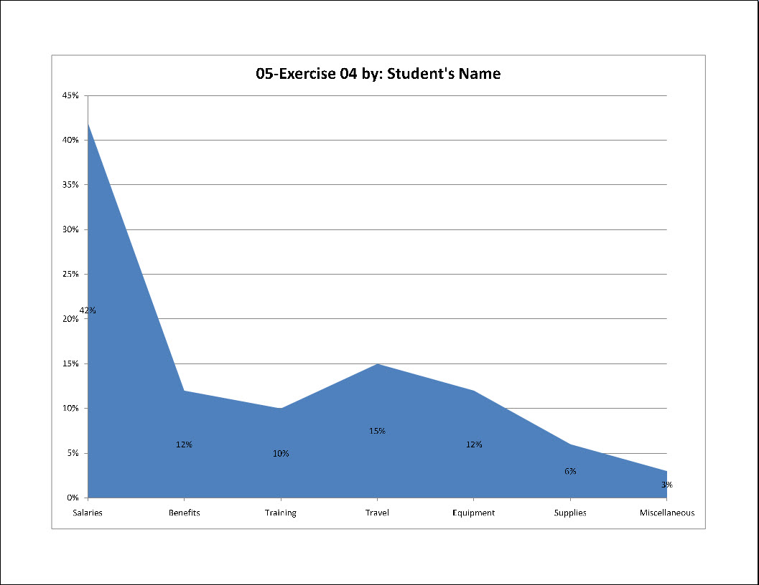
- Add a Chart Title above chart with “5-4 by: Your Name”.
- Change the font of the title and data labels.
- Change the color of the chart data.
- Add 3 formatting changes to the table (Sheet 1).
  - Font, Color, Border, Fill/Shading/Cell Styles…
- Save again and close the worksheet.

Exercise 5 {5 points}
- Open HandInOut\C-Nielsen\Hand-Out\CTech\Excel\05-Designs.
- Save as My Documents\CTech\Excel\5-5.
- Add a Totals Row with formula (Sum) to the bottom of the data (Row 11)
- Create a 3-D Clustered Column chart for the data in cells A3 through B9.
- Move the chart location to a new sheet.
- Switch the Row/Columns of the chart.
  - Hints:
    - Click Switch Row/Column on the Chart Tools Design Tab, Data Group
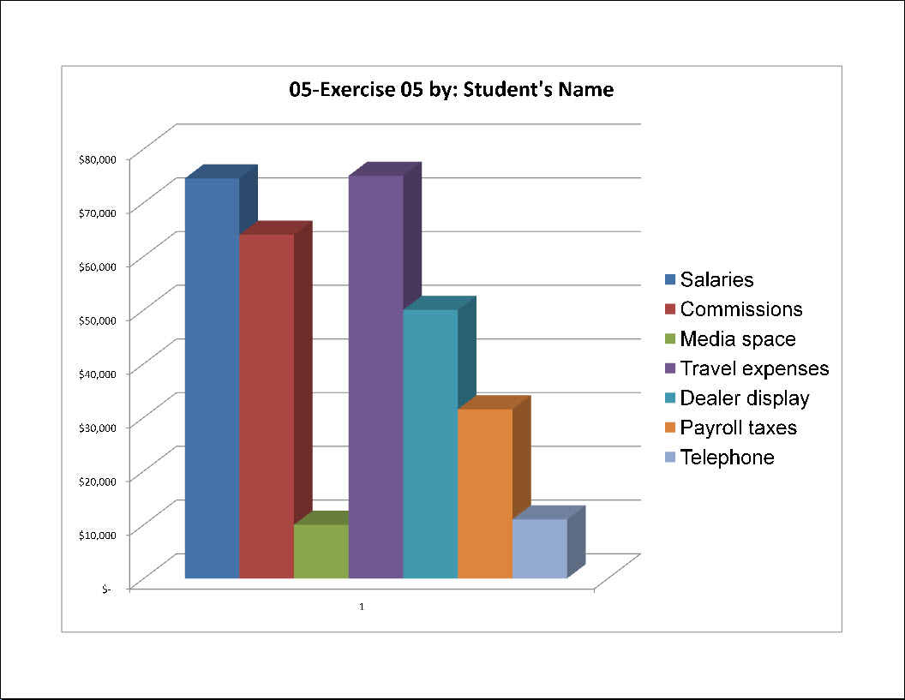
- Remove the horizontal axis and gridlines
  - Hint:
    - Chart Tools Layout Tab, Axes Group
      - Axes, Horizontal Axis, No Axis
      - Gridlines, Horizontal Gridlines, No Gridlines
- Change the font of the Legend to 20-point Arial.
- Add a Chart Title above chart with “5-5 by: Your Name”.
- Change the font of the Chart Title to 20-point Arial.
- Save again and close the worksheet.

Exercise 6 {5 points}
- Open HandInOut\C-Nielsen\Hand-Out\CTech\Excel\05-Candy.
- Save as My Documents\CTech\Excel\5-6.
- Sort the data by brand (A-Z).
- Add a Header with filename on the right and adate on the left.
- Create a Doughnut chart for the data in cells A3 through B12.
- Move the chart location to a new sheet.
- Change the font of the Legend.
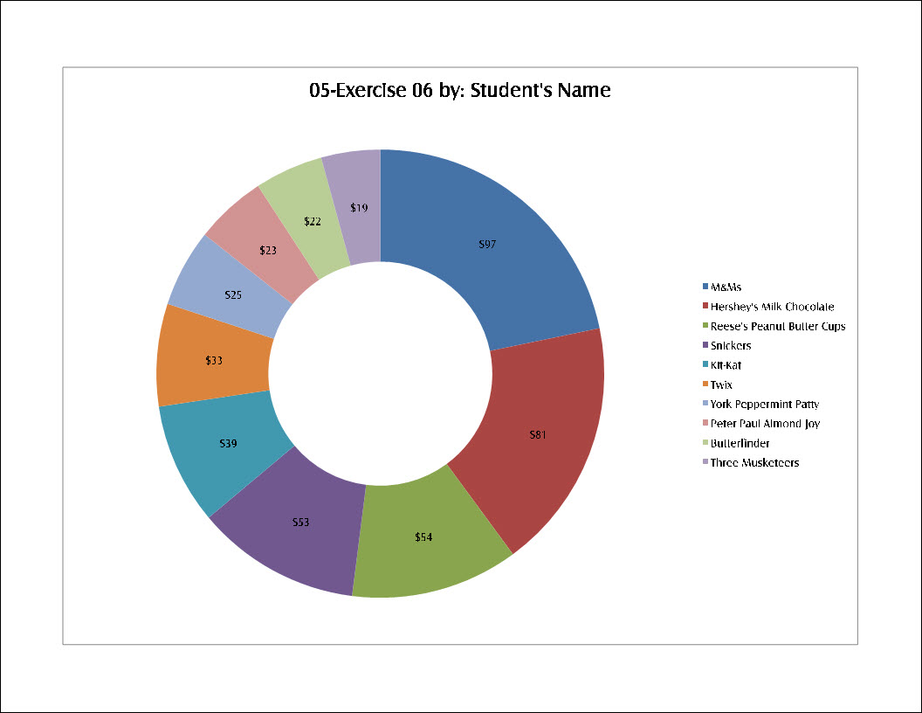
- Show the data labels for all segments.
  - You decide the placement
- Change the font of the Data Labels to match the Legend.
- Add a Chart Title above chart with “5-6 by: Your Name”.
- Change the font of the Chart Title to match the Legend.
- Save again and close the worksheet.

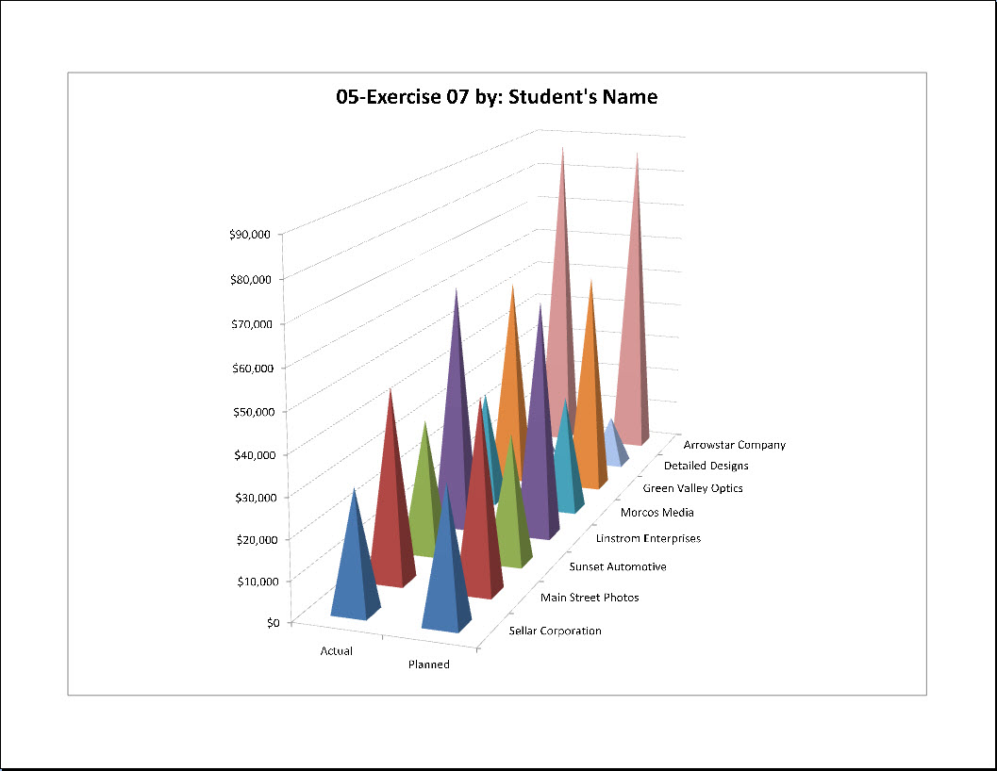
Exercise 7 {5 points}
- Open HandInOut\C-Nielsen\Hand-Out\CTech\Excel\05-Customer.
- Save as My Documents\CTech\Excel\5-7.
- Add 3 formatting changes to the table.
- Add a Totals Row and formula for Columns B & C.
- Create a 3-D Pyramid (in columns charts) chart for the data in cells A1 through C10.
- Move the chart location to a new sheet.
- Switch the Row/Columns of the chart.
- Remove the legend from the chart.
- Add a Chart Title above chart with “5-7 by: Your Name”.
- Change the coloring of the chart.
- Change the font of the title.
- Save again and close the worksheet.
Exercise 8 {5 points}
- Open HandInOut\C-Nielsen\Hand-Out\CTech\Excel\05-Beverage.
- Save as My Documents\CTech\Excel\5-8.
- Add 3 formatting changes to the table.
- Change the chart type to Line chart.
- Remove the legend from the chart.
- Show the right data labels for all line points.
- Change the font of the Data Labels to 12-point font of your choice.
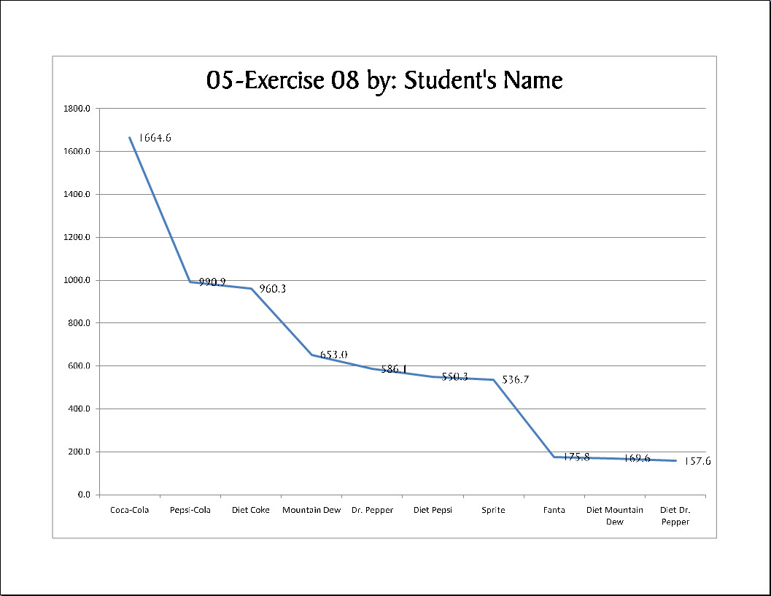
- Add a Chart Title above chart with “5-8 by: Your Name”.
- Change the font of the Chart Title to 28-point matching font.
- Add 2 formatting changes to the chart.
- Save again and close the worksheet.

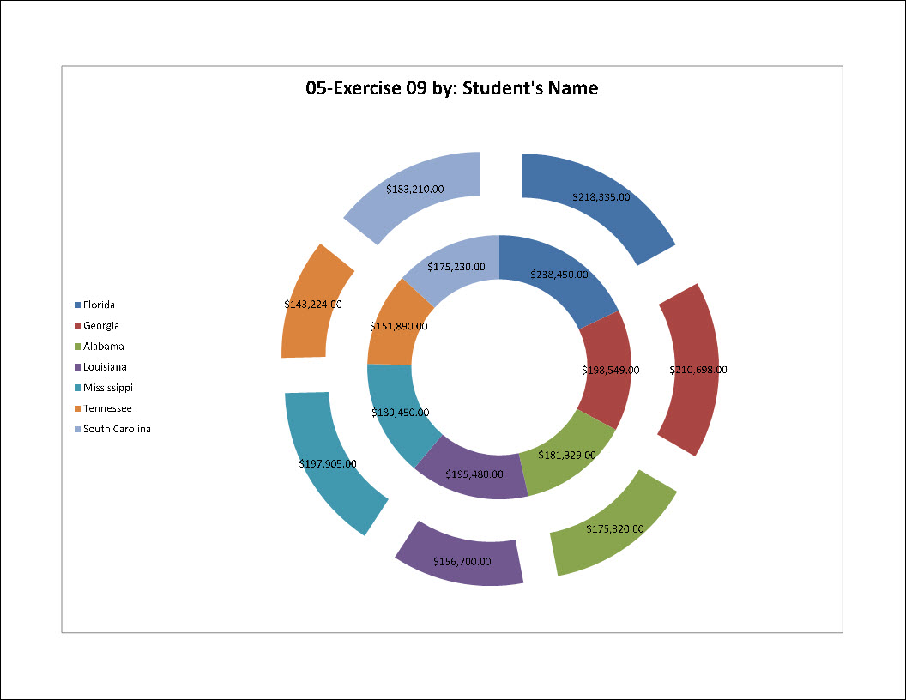
Exercise 9 {5 points}
- Open HandInOut\C-Nielsen\Hand-Out\CTech\Excel\05-Figures.
- Save as My Documents\CTech\Excel\5-9.
- Add a Line Sparkline to to Column D. (Data Set: Column B and C)
- Create an Exploded Doughnut chart for the data in cells A3 through C9.
- Move the chart location to a new sheet.
- Move the legend to the left of the chart.
- Show the data labels for all the pieces.
- Add a Chart Title above chart with “5-9 by: Your Name”.
- Change the fonts for title, data labels, and legends.
- Save again and close the worksheet.

Exercise 10 {5 points}
- Open HandInOut\C-Nielsen\Hand-Out\CTech\Excel\05-Hours.
- Save as My Documents\CTech\Excel\5-10.
- Create a Stacked Bar chart for the data in cells A2 through B7.
- Move the chart location to a new sheet.
- Switch the Row/Columns of the chart.
- Move the legend to the bottom of the chart.
- Change the font of the title and legend.
- Add 3 formatting changes.
- Add a Chart Title above chart with “5-10 by: Your Name”.
- Save again and close the worksheet.

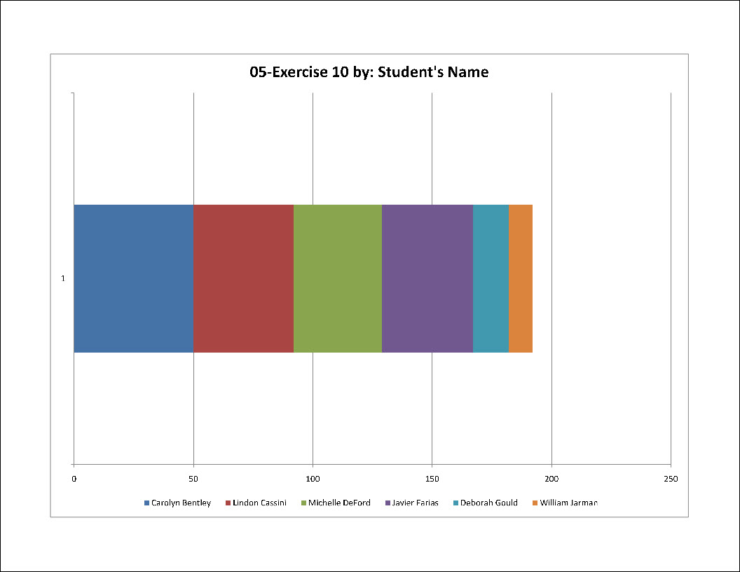
**Click and drag all exercises to your folder in the Teacher Hand-In**

