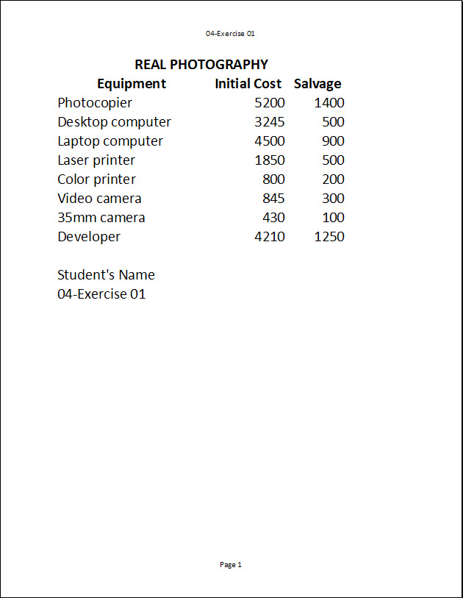
Exercise 1 {5 points}
- Open HandInOut\C-Nielsen\Hand-Out\CTech\Excel\04-Photography.
- Save as My Documents\CTech\Excel\4-1.
- Change the margins to “Wide”.
- Hints:
- Click the Margin on the Page Layout Tab, Page Setup Group
      - Click Wide
- Change the orientation to portrait.
- Hints:
    - Click Orientation on the Page Layout Tab, Page Setup Group
      - Click Portrait
- Create a Header with the filename “4-1”.
- Hints:
- Click the Header & Footer on the Insert Tab, Text Group
      - Click Header on the Header & Footer Tools Tab, Header & Footer Group
        - Click “4-1”
- Create a Footer with “Page 1”.
- Hints:
- Click the Header & Footer on the Insert Tab, Text Group
      - Click Footer on the Header & Footer Tools Tab, Header & Footer Group
        - Click “Page 1”
- Change the font (readable) and font size of the document
  - Keep the document on 1 page
- Add your first and last name two rows below the data and add “#4-1” below it.
- Save again and close the worksheet.
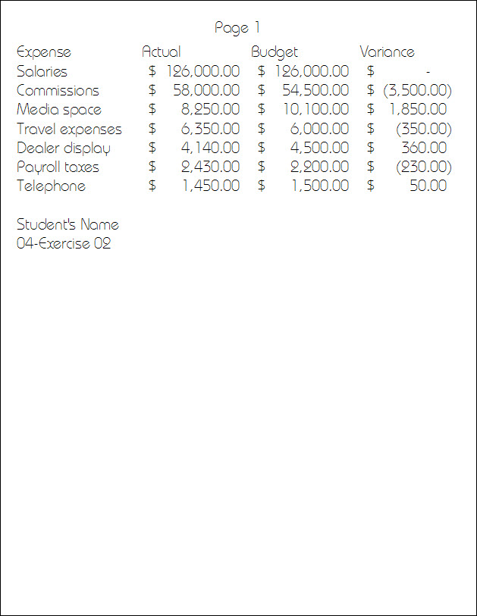
Exercise 2 {5 points}
- Open HandInOut\C-Nielsen\Hand-Out\CTech\Excel\04-Expense.
- Save as My Documents\CTech\Excel\4-2.
- Change the margins to “Narrow”.
- Hints:
- Click the Margin on the Page Layout Tab, Page Setup Group
      - Click Narrow
- Create a Header with “Page 1”.
- Hints:
- Click the Header & Footer on the Insert Tab, Text Group
      - Click Header on the Header & Footer Tools Tab, Header & Footer Group
        - Click “Page 1”
- Change the color of the table font.
- Change the font and font size of the document
  - Keep it on 1 page
- Change the numbers to Accounting Number Format for cells B2 through D8.
- Add your first and last name two rows below the data and add“#4-2” below that.
- Save again and close the worksheet.
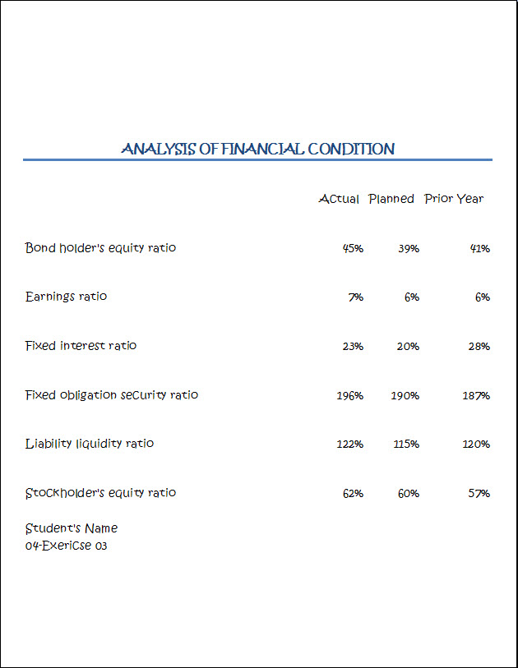
Exercise 3 {5 points}
- Open HandInOut\C-Nielsen\Hand-Out\CTech\Excel\04-Financial.
- Save as My Documents\CTech\Excel\4-3.
- Change the numbers to Percent Style with no decimals for cells B3 through D8.
- Change the row height to 60 for Rows 1 through 8.
- Center the worksheet horizontally and vertically on the printed page.
  - Hints:
    - Click the Page Setup dialog box launcher on the Page Layout Tab, Page Setup Group.
      - Change to the Margins tab
        - At Center on Page
          - Put a ✓ in front of Horizontally
          - Put a ✓ in front of Vertically
            - Click OK
- Sort the spreadsheet by the names of the ratio (A to Z).
  - Hints:
    - Select cells A3 through D8
      - Click Sort & Filter on the Home Tab, Editing Group
        - At the drop down list
          - Click Sort A to Z
- Merge and Center the Title of the document
- Change the title to Title Style
- Change the font.
  - AutoFit the columns if necessary.
- Add your first and last name and add “#4-3” to below it.
- Save again and close the worksheet.

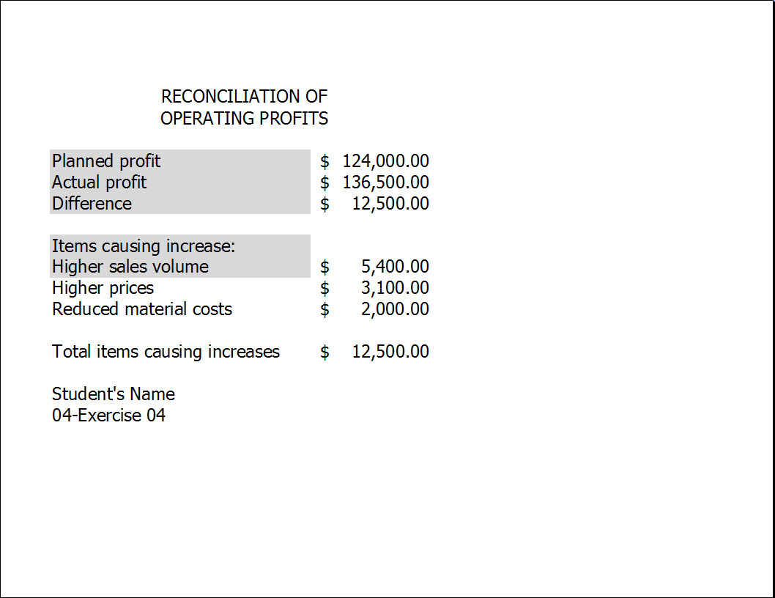
Exercise 4 {5 points}
- Open HandInOut\C-Nielsen\Hand-Out\CTech\Excel\04-Profits.
- Save as My Documents\CTech\Excel\4-4.
- Spellcheck the spreadsheet to correct the mistakes.
  - Hints:
    - Click Spelling on the Review Tab, Proofing Group
      - Fix each error
- Add the formula for the “Total Items Causing Increases”
  - Hint: =SUM(B8:B10)
- Change the numbers to Accounting Number Format for cells B3 through B12.
- Change the row height to 80 for Row 1.
- Change the orientation to landscape.
- Customize the margins to .5” on all sides.
- Change the font color.
- Add a border to all data.
- Add your first and last name and add “#4-4” below it.
- Save again and close the worksheet.
Exercise 5 {5 points}
- Open HandInOut\C-Nielsen\Hand-Out\CTech\Excel\04-Test.
- Save as My Documents\CTech\Excel\4-5.
- Sort the spreadsheet by the student scores (smallest to largest) for Test 1 Score.
  - Hints:
    - Select cells A2 through B19
      - Click Sort on the Data Tab, Sort & Filter Group
        - At the Sort Dialog Box
          - Column Sort by: Change to Column B (Quiz 1 Score)
            - Click Ok
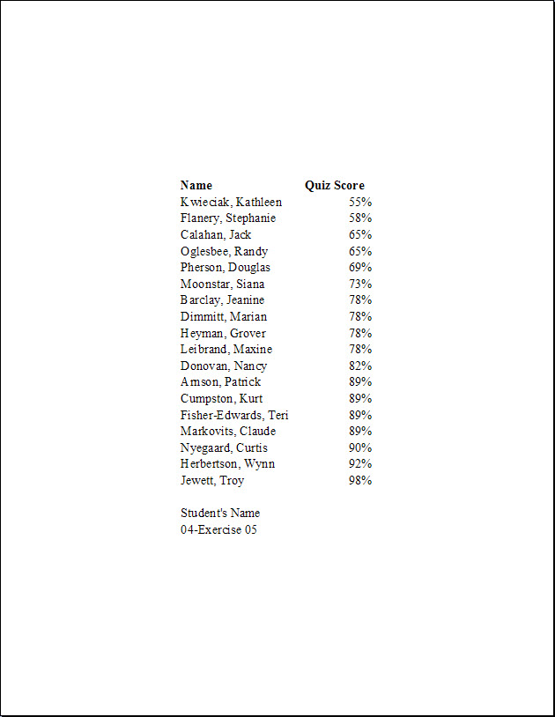
- Find the occurrences of “Test” and replace with “Quiz.
  - Hints:
    - Click Find & Select on the Home Tab, Editing Group
      - Click Replace
        - At the Find and Replace dialog box
          - At Find what: Type “Test”
          - At Replace with: Type “Quiz”
          - Click Replace All
- Change the orientation to portrait.
- Center the worksheet horizontally and vertically on the printed page.
  - Hints:
    - Click the Page Setup dialog box launcher on the Page Layout Tab, Page Setup Group.
      - Change to the Margins tab
        - At Center on Page
          - Put a ✓ in front of Horizontally
          - Put a ✓ in front of Vertically
            - Click OK
- Change A1:D1 to Heading 1 Style, and change the color.
- Add your first and last name and add “#4-5” below it.
- Save again and close the worksheet.
Exercise 6 {5 points}
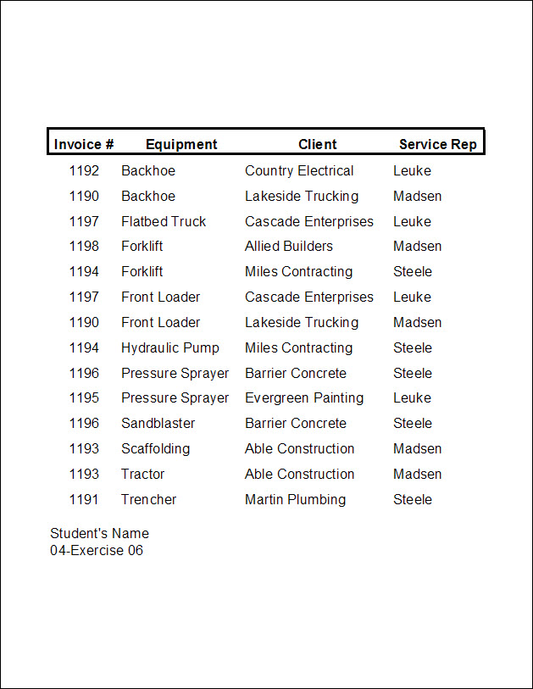
- Open HandInOut\
C-Nielsen\Hand-Out\CTech\Excel\04-Equipment.
- Save as My Documents\CTech\Excel\4-6.
- Center the worksheet horizontally and vertically on the printed page.
- Sort the spreadsheet by Equipment (A to Z) and also by Client (A to Z).
  - Hints:
    - Select cells A2 through D15
      - Click Sort on the Data Tab, Sort & Filter Group
        - At the Sort Dialog Box
    - Primary Sort
      - Column Sort by: Change to Equipment
    - Secondary Sort
      - Click Add Level
        - Column Sort by: Change to Client
  - Click Ok
- Find all occurrences of “Monahan” and replace with “Madsen”.
- Add a Footer with the Page number on the right, and Date on the left.
- Add your first and last name to cell A17 and add “#4-6” to cell A18.
- Save again and close the worksheet.

Exercise 7 {5 points}
- Open HandInOut\C-Nielsen\Hand-Out\CTech\Excel\04-Figures.
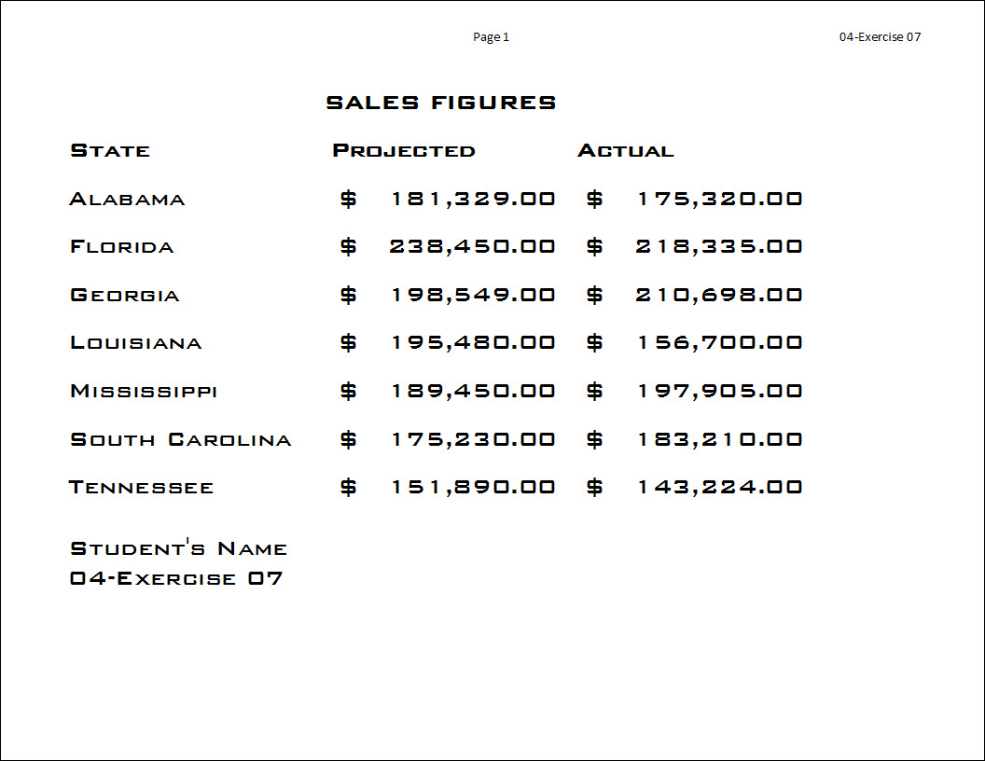
- Save as My Documents\CTech\Excel\4-7.
- Change the margins to “Normal”.
- Sort the spreadsheet by State (A to Z).
- Change the row height to 40 for Rows 1 through 9.
- Create a Header with the page number and filename “Page 1, 4-7”.
- Rotate the Title Clockwise, and adjust the row width to fit it.
  - Hint: Merge the A1:C1 first
- Add Shading to the table.
  - Hint: Borders and Shading…
- Add your first and last name and add “#4-7” below it.
- Save again and close the worksheet.
Exercise 8 {5 points}
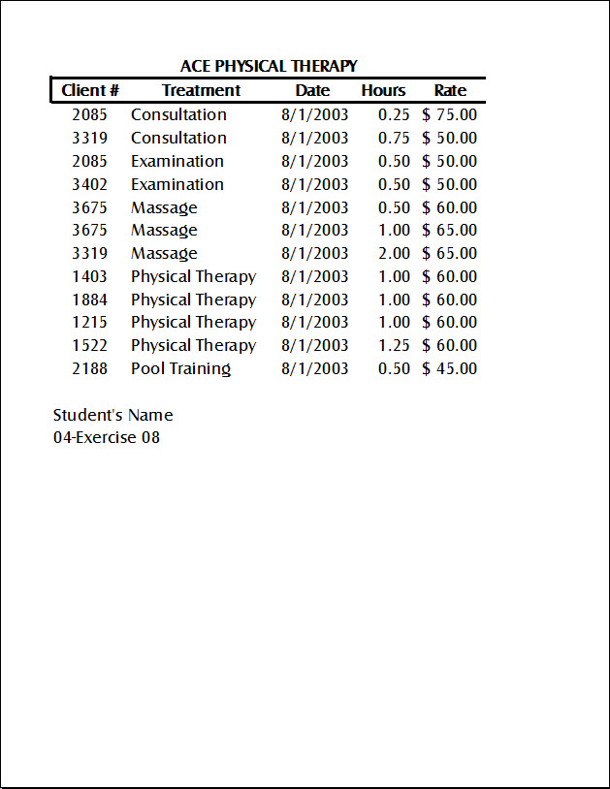
- Open HandInOut\C-Nielsen\Hand-Out\CTech\Excel\04-Physical.
- Save as My Documents\CTech\Excel\4-8.
- Spellcheck the spreadsheet to correct the mistakes.
- Find all occurrences of “3102” and replace with “3319”.
- Sort the spreadsheet by Treatment (A to Z).
- Automatically adjust the width of all Columns.
- Change the font and font color
- Add shading or a border to the table.
- Center the data horizontally and vertically on the page.
- Add your first and last name and add “#4-8” below it.
- Save again and close the worksheet.

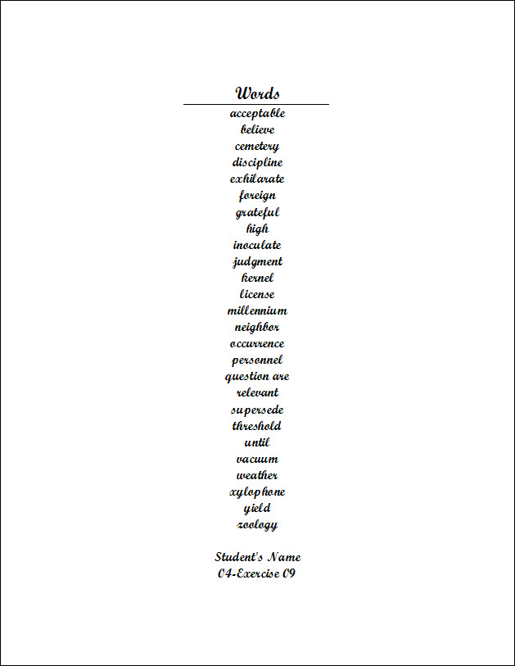
Exercise 9 {5 points}
- Open HandInOut\C-Nielsen\Hand-Out\CTech\Excel\04-Spelling.
- Save as My Documents\CTech\Excel\4-9.
- Change the orientation to portrait.
- Customize the margins to be 1” for all.
- Spellcheck the spreadsheet to correct the mistakes.
- Sort the spreadsheet by Words (Z to A)
- Center the worksheet horizontally on the printed page.
- Add a cell style to the title.
- Change the font.
- Add your first and last name and add “#4-9” below it.
- Save again and close the worksheet.
Exercise 10 {5 points}
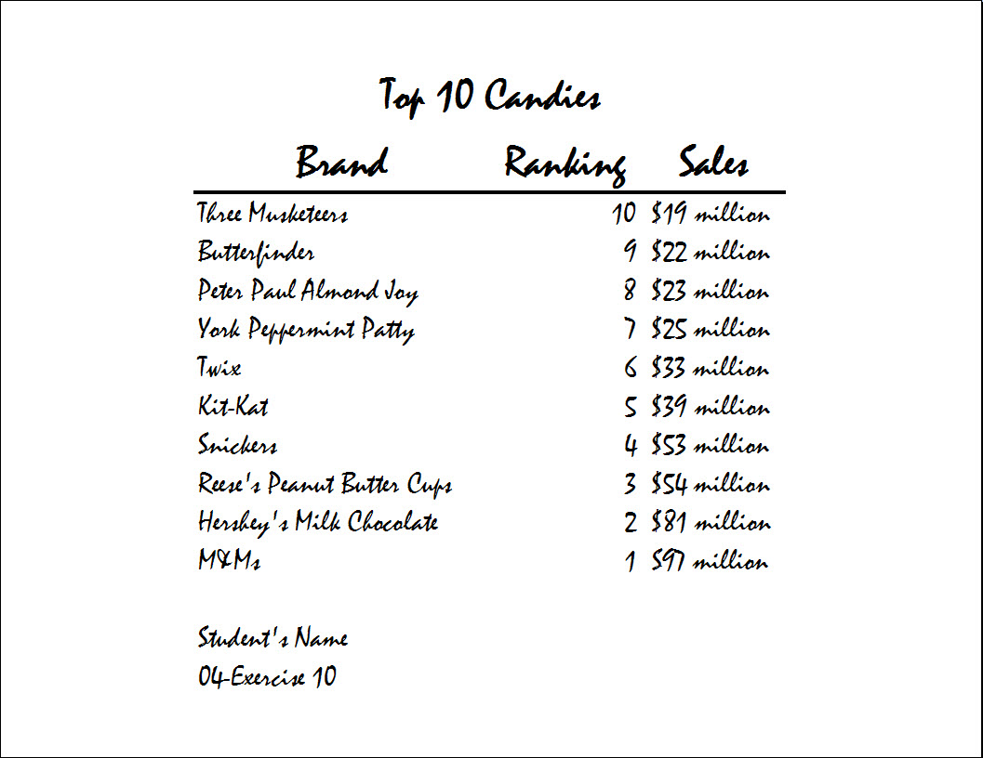
- Open HandInOut\C-Nielsen\Hand-Out\CTech\Excel\04-Candy
- Save as My Documents\CTech\Excel\4-10.
- Change the orientation to landscape.
- Find all occurrences of “billion” and replace with “million”.
- Sort the spreadsheet by Sales (A to Z)
- Change the row height to 40 for Rows 3 through 12.
- Change the margins to Narrow.
- Change the font.
- AutoFit columns if necessary.
- Add formatting to your sheet.
  - Example: Border, Shading, Cell Styles, Font Size or Color.
- Add a Header with your name and a Footer with the file name and the date.
- Save again and close the worksheet.

**Click and drag all exercises to Teacher Hand-In\C Nielsen**

