Follow to learn Operating Systems

- Windows XP – Operating System
  - Desktop – main portion of the screen; can place tools her to help make using the computer easier
    - 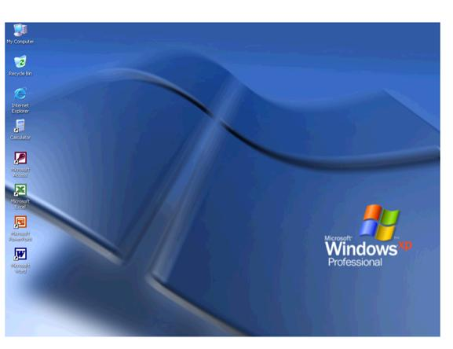Icons – visual symbols that represent programs, files, or folders
      - Double click on an icon to access
      - Double click on the Word
        - Minimize the program – click the 3rd button on the top right

- Taskbar – at the bottom of the screen; leads to different tasks or applications
  - Divided into 4 Areas
    - Start – access to different tasks or applications
      - Click Start, Programs, Internet Explorer
        - Should get a Stop Sign because the Internet is blocked (Do Not Close)
Start
Quick Launch
Program Area
System Tray
    - Quick Launch – access to different tasks or applications
      - Click Show Desktop
    - Program Button Area – programs that are open
      - Click on the Word Program to make it active
    - 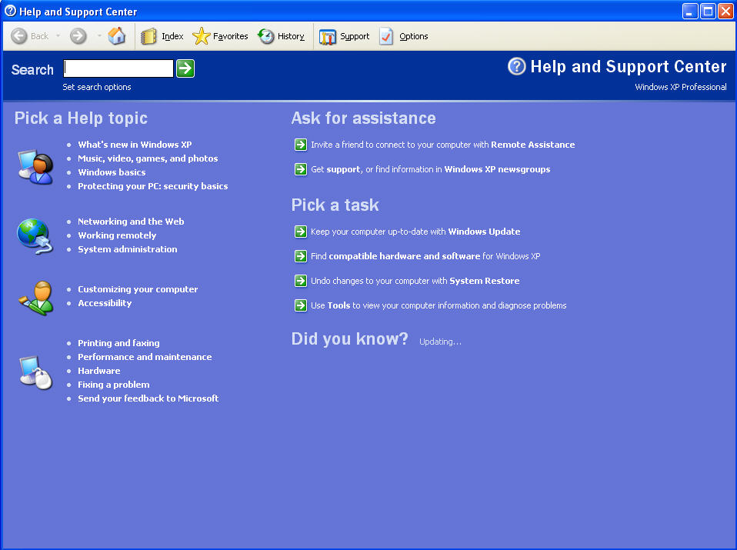System Tray – programs running in the background

- Help and Support - Gives you possible topics on issues you want help with
  - Click Start, Help and Support
    - Type “Games” in the Search Box
      - The suggested topics are listed to possibly help find a solution to a problem.

- 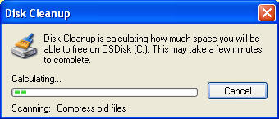Disk Cleanup - Scans your hard drive and identifies unnecessary files that can be deleted
  - Click Start, Programs, Accessories, System Tools, Disk Cleanup
    - Click Cancel since this will take too long
        - Cancel is a Command Button

- 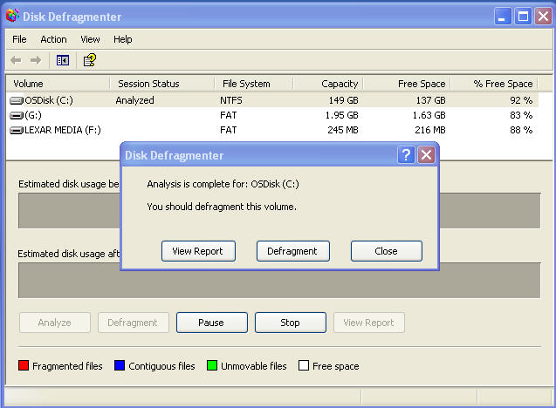Disk Defragmenter - Scans the drive and puts things in a better order to free up space on the drive
  - Click, Start, Programs, Accessories, System Tools, Disk Defragmenter
    - Click Analyze to start the hard drive analysis
      - Click Close
    - Click the X to Close the program

- Search for Files/Folders - Allows you to find files/folders that you have misplaced
  - 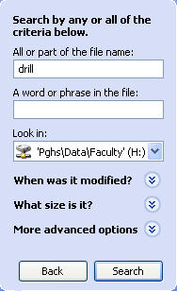Click Start, Search, For Files and Folders
    - Click Green Arrow next to All Files and Folders
      - In All or part of file name, type “Drill”
      - In “Look in” change to your V:\ (Student Number) Drive
        - Click Search
    - Notice the files that were found.
      - 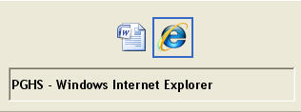Click the Red X to close the dialog box

- Toggle through open Programs – Lets you change the active program
  - Press Alt + Tab
    - Hold the Alt Key and Press Tab to move between programs
      - 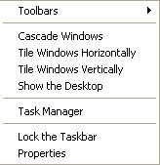Release the keys when Word is selected

- Tiling Windows – lets you view multiple Programs at one time
  - Right click on the Taskbar; click Tile Windows Vertically
  - Right click on the Taskbar; click Undo Title
  - Right click on the Taskbar’ click on Tile Windows Horizontally
    - In Word, click Maximize

- Closing programs – shuts the program down
  - Click the X in the upper right corner of each application that is open

